**6th Grade ME1 Benchmark 1**

**(Chapters 1-7)**

1. (6.2D) A weather report lists the temperatures in Minnesota for the past week. In which list are the temperatures in increasing order?

A -1˚F, -7˚F, -10˚F, 0˚F, 8˚F, 12˚F, 30˚F

B 0˚F, -1˚F, -7˚F, 8˚F, -10˚F, 12˚F, 30˚F

C -10˚F, -7˚F, -1˚F, 0˚F, 8˚F, 12˚F, 30˚F

D 30˚F, 12˚F, 8˚F, 0˚F, -1˚F, -7˚F, -10˚F

2. (6.4B) Laura can wrap 24 presents in 3 hours. How many presents can she wrap in 5 hours?

A 26

B 40

C 30

D 36

3. (6.7A) Simplify the expression below.

12 – 2 + 3 • 2 – 32

A 5

B 6

C 7

D 10

4. (6.3C) The model represents the equation x + 5 = -2.

**KEY**

+1 = $⊕$-1 = ⊖ x = ⊠

⊠ $⊕$ $⊕$ $⊕$ $⊕ ⊕$ = ⊖ ⊖

What is the value of x?

A x = -7

B x = 3

C x = -3

D x = -2

5. (6.9A) Amy is teaching 8 preschoolers how to swim. 5 of them are girls. Which of the following equations can be used to find x, the number of boys in the class?

A 5 + x = 8

B 5 – 8 = x

C 5 – x = 8

D 8 + x = 5

6. (6.11A) Which point is at (-4, 3)?

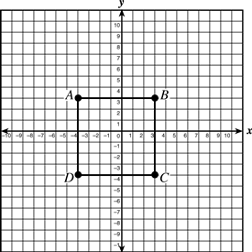

A A

B B

C C

D D

7. (6.5A) Which list contains a set of equivalent numbers?

A , 0.8, 8%

B , 0.37, 37%

C , 0.03, 30%

D , 0.55, 55%

8. (6.6C) Which graph below represents the equation $y=\frac{5}{3}x$?

|  |  |  |  |
| --- | --- | --- | --- |
|  | A | C | C |
|  |  |  |  |
|  | B |  | D |
|  |  | D |  |
|  |  |  |  |

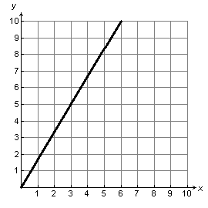

Distances

Distance on map (cm)

Actual distance (mi)

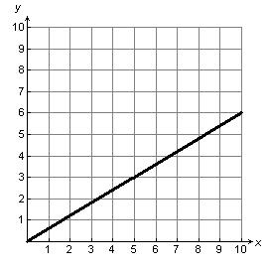

Distances

Distance on map (cm)

Actual distance (mi)

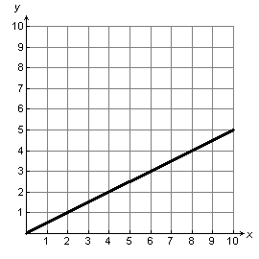

Distances

Distance on map (cm)

Actual distance (mi)

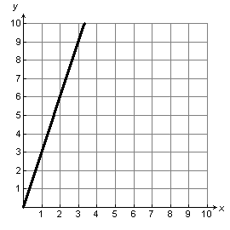

Distances

Distance on map (cm)

Actual distance (mi)

9. (6.4C) At the middle school Roberta attends, there are 260 Grade 8 students, 307 Grade 7 students, and 200 Grade 6 students. Which ratio best compares the number of students in Grade 6 to the number of students in Grade 8 at Roberta's school?

A 260:200

B 130:100  
C 10:13  
D 6:8

10. (6.7A) Which expression best shows the prime factorization of 720?

a. 22 x 5 x 62  
b. 2 x 32 x 52  
c. 2 x 3 x 53   
d. 24 x 5 x 32

11. (6.2A) Which of the following statements is true?

A In a Venn diagram representing the set of rational numbers, the set of integers would be nested inside of the set of whole numbers.

B In a Venn diagram representing the set of rational numbers, the set of whole numbers would be nested inside of the set of integers.

C In a Venn diagram representing the set of rational numbers, the set of rational numbers would be nested inside of the set of whole numbers.

D In a Venn diagram representing the set of rational numbers, the set of rational numbers would be nested inside of the set of integers.

12. (6.2B) Identify the opposite and the absolute value of the number 5.

A Opposite: -5; Absolute Value: 5

B Opposite: $\frac{1}{5}$; Absolute Value: 5

C Opposite: 5; Absolute Value: -5

D Opposite: $-\frac{1}{5}$; Absolute Value: -5

13. (6.2C) Identify the value of point, P, for the number line below.

0 1 P 2

A 1.2

B 1.3

C 1.4

D 1.5

14. (6.3D) Simplify:

Record your answer and fill in the bubbles on the grid. Be sure to use the correct place value.

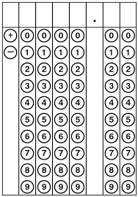

15. (6.4G) Claymart is having a 20% off sale on all of its vases. Which of the following is equivalent to 20%?

A 0.02

B

C 0.02

D

16. (6.5B) Marta went fishing and caught 18 trout which is 5 percent of the population of trout in that particular river. How many trout were in the river right before Marta went fishing?

A 90

B 108

C 360

D 400

17. (6.7B) Which of the following choices is an algebraic expression?

A

B

C

D

18. (6.9B) Which of the following number line graphs represents the solution to the inequality $x+17>15?$

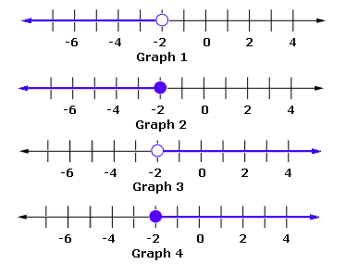

A Graph 1 C Graph 3

B Graph 2 D Graph 4

19. (6.10B) Determine which of the following choices makes the following inequality true:

$x-7<2$

A $-3$

B 9

C 10

D 100

20. (6.3E) Simplify: $1.8÷0.5$

Record your answer and fill in the bubbles on the grid. Be sure to use the correct place value.



21. (6.7D) Which of the following expressions is equivalent to $15(x+2)$ and which property was used to generate the equivalent expression?

A $\left(15x\right)+2$ by associative property

B $\left(x+2\right)+15$ by commutative property

C $15+2x$ by identity property

D $15x+30$ by distributive property

22. (6.10A) Mrs. Serviere has $63 and wants to use it to pay for her cafeteria lunches ahead of time. If each lunch costs $3.50, how many lunches could she buy with her money? Model an equation to represent the situation, and solve for the number of lunches, *x*.

A

B

C

D

23. (6.2E and 6.3A) Which of the following expressions is NOT equivalent to *b* | *a* ?

A

B

C

D

24. (6.3B) If is any number greater than 0, then which of the following statements is always true for $0.875x$?

A $0.875x$ is less than 1.

B $0.875x$ is less than $x$.

C $0.875x$ is more than $x$.

D $0.875x$ is more than 1.

25. (6.6B) The total price Samson Middle School pays for museum tickets depends on how many Samson students go to the museum on the field trip day. Below is a table representing the total entrance fee for various amounts of students.

|  |  |
| --- | --- |
| Number of Students, *x* | Total Entrance Fee, *y* |
| 0 | 0 |
| 5 | $20 |
| 10 | $40 |
| 15 | $60 |
| 20 | $80 |

Which equation represents the relationship between the independent and dependent quantities in this situation?

A $y=20x$

B $y=20+x$

C $y=4x$

D $y=5x$

**Answer Key for 6th Grade ME1 Benchmark 1**

1. **C**
2. **B**
3. **C**
4. **A**
5. **A**
6. **A**
7. **D**
8. **C**
9. **C**
10. **D**
11. **B**
12. **A**
13. **C**
14. **-4**
15. **D**
16. **C**
17. **B**
18. **C**
19. **A**
20. **3.6**
21. **D**
22. **C**
23. **D**
24. **B**
25. **C**