**7th Grade ME2 Benchmark 1**

**(Chapters 1-9)**

1.

(7.7A) Which equation best represents the relationship between *x* and *y* below?

|  |  |
| --- | --- |
| ***x*** | ***y*** |
| 0 | -7 |
| 3 | -5 |
| 6 | -3 |
| 9 | -1 |
| 12 | 1 |

A $y=2x-7$

B $y=\frac{x}{3}-7$

C $y=-2x-7$

D $y=\frac{2}{3}x-7$

Answer: D

2.

(7.10B) The following number line represents the solution for which inequality?

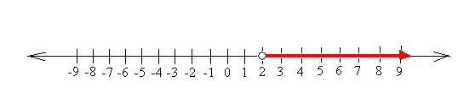

A $3x+4>10$

B $4x-5≥3$

C $2x+4<2$

D $12>6x$

Answer: A

3.

(7.3A) Carl has $23 and needs to buy some paint. If paint sells for $5.95 per gallon, including tax, how many gallons of paint can he purchase?

a) 3 b) 4 c) 5 d) 6

Answer: A

4.

(7.10A) Monique needs $6.00 in quarters for a coin-operated washing machine. She already has five quarters. Which equation can be used to find *x*, the number of additional quarters Monique needs in order to have enough money to wash her clothes?

A $0.25x+1.25=6$

B $1.25+x=6$

C $x-6=24$

D $1.25x+6=24$

Answer: A

5.

(7.11A) A 50-gallon tank is draining at a rate of 2.5 gallons per minute. Model an equation to represent the time, *t*, in minutes it will take the tank to only have two gallons left in it. Solve for *t*.

$2+2.5t=50; t=18 minutes$

$2.50+2t=50; t=23.75 minutes$

$50-2.5t=2; t=19.2 minutes$

$50-2.5t=2; t=20 minutes$

Answer: C

6.

(7.3B) What is the area of a rectangle that is 2 feet long and 3 inches wide?

a) .25 ft2 b) .5 ft2 c) .6 ft2 d) 1 ft2

Answer: B

7.

(7.2A) Which subset of the rational numbers would best describe the type of numbers in the following set:

$\left\{-18, -13,-7, 0, 2, 315\right\}$

1. Whole Numbers
2. Integers
3. Natural Numbers
4. Negative Numbers

Answer: B

8.

(7.7A) A pool has 2 feet of water in it, and water is being added to it at a rate of 3 inches per hour. Which equation represents the relationship between *y*, the height of the water in inches, and *x*, the number of hours water is being added?

A $y=3x+2$

B $y=3x+24$

C $y=2x+3$

D $y=2+\frac{3}{x}$

Answer: B

9.

(7.4A) Which of the following equations represents the distance, *d*, a car travels if it is moving at 55 miles per hour? Let *t* represent the number of hours the car has been traveling.



$d=55+t$

$t=55+t$

$d=55t$

$t=55d$

Answer: C

10.

(7.4C) Which of the following equations has a constant of proportionality of 7?

A. $y=7x+5$

B. $y=5x+7$

C. $y=7$

D. $y=7x$

Answer: D

11.

(7.10B) The following number line represents the solution for which inequality? 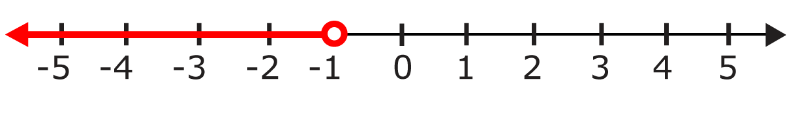

A $-3x+5<8$

B $3x+10≤13$

C $x+4>3$

D $3x+6<3$

Answer: D

12.

(7.2A) Which of the following statements is true?

1. The set of Whole Numbers is a subset of the Integers.
2. The set of Integers is a subset of the Whole Numbers.
3. The set of Whole Numbers contains all of the Integers.
4. All Integers are contained in the set of Negative Whole Numbers.

Answer: A

13.

(7.11A) Tickets for a play cost $5.00 each and40 tickets have already been sold. Model an inequality to represent the number of additional tickets, *x*, that need to be sold in order for the play revenue to be at least $1200. Solve the inequality.

A $40+5x≥1200; x≥232 tickets$

B $5x+200≥1200; x≥200 tickets$

C $40+5x≤1200; x≤232 tickets$

D $5x+200<1200; x<200 tickets$

Answer: B

14.

(7.10A) Michelle is *m* years old. David’s age, *d*, is 6 more than 2 times Michelle’s age. Which of the following equations best represents this situation?

A. *d* = (6 + 2)*m* B. *m* = 2*d* + 6 C. *d* = 2*m* + 6 D. *m* = (6 + 2)*d*

Answer: C

15.

(7.10C) Which problem situation does the following equation best represent?

$16x-7=41$

a. Skylar measured the time in hours, *x*, it would take her to ride her bike 41 miles from home to school traveling at 16 miles per hour with a 7-mile per hour headwind.

b. Hank bought *x* concert tickets for $16.00 each. He also bought a $7.00 popcorn and spent a total of $41.00.

c. The temperature started at 16 degrees Celsius, decreased by 7 percent, and ended up at 41 degrees Fahrenheit.

d. Leonel bought *x* shirts at $16.00 each with a $7.00 off coupon. His total without tax was $41.00.

Answer: D

16.

(7.4A) Oscar made a scale drawing of his backyard. In his drawing 1 inch represents 5 feet.

Which graph best represents this relationship?



Answer: F

17.

(7.3A) Sylvia bought 14 bananas at $0.11 per banana. How much did the bananas cost?

a) $15.40 b) $1.41 c) $1.54 d) $1.27

Answer: C

18.

(7.3B) John has $100 and needs to buy batteries for his Christmas presents. Batteries come in packages of 4 for $4.95 per package, including taxes. If he needs 15 batteries for his toys, how much change should he receive after purchasing the batteries?

a) $80.20 b) $19.80 c) $85.15 d) $79.80

Answer: A

19.

(7.4A) Which of the following situations does the model represent?

*y = 0.65x*

1. Balloons cost $0.65 a piece. What is *y*, the number of balloons *x* amount of dollars will buy?
2. Balloons cost $0.65 a piece. What is *y*, the cost of buying *x* number of balloons?
3. Balloons cost $0.65 a piece. What is *y*, the change received if buying *x* number of balloons?
4. Balloons cost $0.65 a piece. What is *y,* the number of balloons you can purchase with *x* number of dollars remaining?

Answer: B

20.

(7.10C) Which problem situation matches the equation below?

*x = 30 – 4(6.5)*

1. Jerod buys movie tickets for $6.50 each. What is *x*, the cost of 30 movie tickets?
2. Sylvia buys four pairs of socks for $6.50 each. What is x, the cost of 30 pairs of socks at $6.50 a pair?
3. Dawn buys four shirts at $6.50 each. What is *x*, the amount of change she receives when she gives the clerk $30?
4. Stephen buys tickets to a play for $6.50 each. What is *x*, the number of tickets he can purchase for exactly $30.00?

Answer: C

21.

(7.11B) Determine which of the given values for *x* makes the following equation true:

0.07x + 4 = 32

a) 514 b) 40 c) 400 d) 340

Answer: C

22.

(7.3A) Ms. Rodroguez needed to make 2 curtains for her home. The larger curtain required 3 1/2 yards of material, and the smaller curtain required 5/8 yard less than the larger one. How much material is needed for the smaller curtain?

**A** 2 1/8 yd

**B** 3 1/8 yd

**C** 2 3/4 yd

**D** 2 7/8 yd

Answer: D

23.

(7.3B) If it takes 1.75 cups of sugar to make a coffee cake, how many cups of sugar does it take to make 6 cakes?

Record your answer and fill in the bubbles on your answer document. Be sure to use the correct place value.

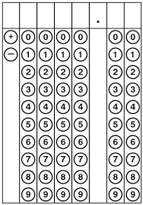

Answer: *x = 10.5 cups*

24.

(7.11B) Determine which of the given values makes the following equation true when *y* =6.

4*x* – 8 = 2*y*

a) *x* = -1 b) *x* = 1 c) *x* = 5 d) *x* = -5

Answer: C

25.

(7.4C) What would be the constant of proportionality for the following table?

|  |  |
| --- | --- |
| ***x*** | ***y*** |
| 0 | 0 |
| 1 | 4.5 |
| 2 | 9 |
| 3 | 13.5 |
| 4 | 18 |

1. 0 B. 4.5 C. 9 D. 18

Answer: B