7th Grade ME2 Benchmark 2
(Chapters 1-13)

1.
(7.2A) Which of the following sets show numbers that would NOT be included in a set of integers?

A $\left\{-5, -4,-3\right\}$

B $\left\{-\frac{1}{2}, -\frac{1}{3},-\frac{1}{4}\right\}$

C $\left\{1, 2, 3\right\}$

D $\left\{-1, 0,1\right\}$

Answer: B

2.
(7.6H) At the fishing tournament in the Laguna Madre, the following fish were caught: 6 Blue Marlin, 48 Sailfish, 62 White Marlin, 80 Trout, and 104 Red Fish. Based on the results to the fishing tournament, what is the probability of catching a trout in the Laguna Madre?

A 80/200

B 4/15

C 300/80

D 80/104
Answer: B

3.
(7.4B) Jordan bought 6 pounds of pears for $4.50. Which of the following is a unit rate that represents Jordan’s purchase?

A $1.33 per pound

B $4.50 per 6 pounds

C 0.75 pounds per dollar

D $0.75 per pound
Answer: D
4.
(7.3B) Sharon is making a sore throat concoction that contains $2\frac{1}{3}$ cups of water, $1\frac{1}{4}$ cup of honey and 1$\frac{1}{8}$ cup of lemon juice. After it is mixed up, it contains too much to fit into a 1-quart jar. How much will she have to remove in order for the mixture to fill the jar completely and not spill over?

A 17/24 cup

B 7/24 cup

C 1/8 cup

D 7/12 cup
Answer: A

5.
(7.4A) Which equation would represent the graph below for distance, d and time, t?

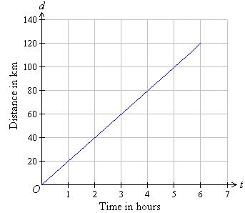

A $t=20d$

B $t=40d$

C $d=20t$

D $d=40t$
Answer: C

6.
(7.4D) The ratio of shoppers to store clerks is 255 to 10 at a local department store. If the store manager decides to increase the number of store clerks by 50%, what will be the new ratio of shoppers to store clerks?

A 17:1

B 15:255

C 255:10

D 10:255
Answer: A

7.
(7.5A) In the figure below, Triangle ABC is similar to Triangle DEF. Which of the following statements is NOT a critical attribute of similarity for these figures?

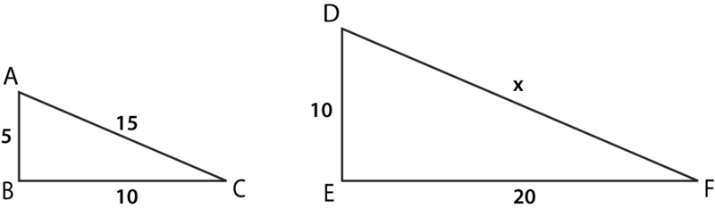

A $∠C≅$ $∠F$

B $\frac{AB}{DE}=\frac{BC}{EF}$

C $\frac{AB}{BC}=\frac{EF}{DE}$

D $\frac{AB}{AC}=\frac{DE}{DF}$
Answer: C

8.
(7.13A) If sales tax is 6.5 percent, what is the total price including tax for an item costing $14.00?

A $0.91

B $14.91

C $13.09

D $15.31
Answer: B

9.
(7.3A) How many 0.3-pound bags of sand could be made from a barrel that has 63.75 pounds of sand in it?

A 21.25 bags

B 19.125 bags

C 211.5 bags

D 212.5 bags
Answer: D

10.
(7.6A) Represent the sample space for the tossing of a coin and throwing of a 6-sided number cube using a list. Let H represent heads and T represent tails.

A H1, H2, H3, T4, T5, T6

B T1, H2, T3, H4, T5, H6

C H1, T2, H3, T4, H5, T6

D H1, H2, H3, H4, H5, H6, T1, T2, T3, T4, T5, T6
Answer: D

11.
(7.12B) George and Crystal conducted a survey at their school asking about the favorite cafeteria meal of students. Their sample contained 30 people. Five students said chicken nuggets, 8 said hamburgers, 3 said enchiladas, and the rest said pizza. Based on their survey, if there are 330 students in the school, how many students would they predict like pizza as their favorite cafeteria meal?

A 154

B 209

C 176

D 14
Answer: A

12.
(7.9C) What is the area of the composite figure below in square yards?
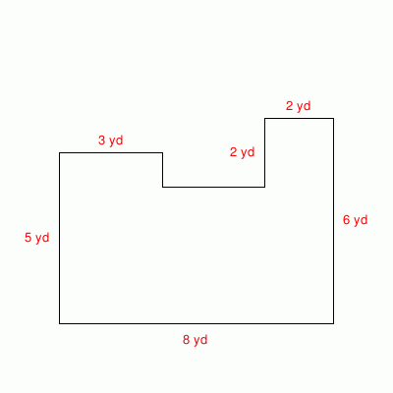

A 30 yd²

B 39 yd²

C 42 yd²

D 43 yd²
Answer: B

13.
(7.6H) Dave is at the batting cages conducting an experiment on left-handed batters. He notices that out of the 192 people at the batting cages, 8 of them are batting left- handed. Based on his observation, how many left-handed batters can he predict for the next 48 batters?

Record your answer and fill in the bubbles on your answer document. Be sure to use the correct place value.

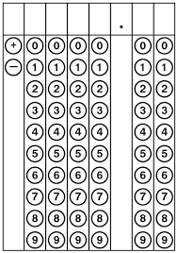
Answer: 2

14.
(7.4D) Mathias pays $250 from his paycheck every month toward his student loan. However, his car needs new tires so he decides to decrease the amount of his loan payment by 20%. How much will he now be paying toward his student loan?

A $230

B $200

C $50

D $270
Answer: B

15.
(7.5C) In the figures below, Triangle ABC is similar to Triangle DEF. If $m∠B=59°$, then what is the measure of $∠E?$

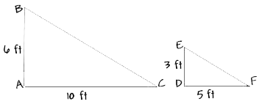

A 29.5$°$

B 59$°$

C 30$°$

D 60$°$
Answer: B

16.
(7.4C) The weight, w, of an object hanging on a spring is proportional to the length, l, that the spring stretches. If a spring stretches 5 cm with a weight of 42 grams, then what is the constant of proportionality?

A 42

B 5

C 8.4

D 0.3
Answer: C

17.
(7.5C) Pentagon ABCDE is similar to Pentagon VWXYZ. If AE = 6 cm, AB = 7 cm, and VW = 5.6 cm, then what does VZ equal?

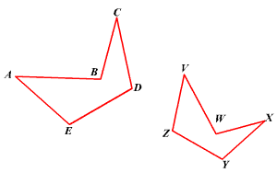
A 4.8 cm

B 6.53 cm

C 6.6 cm

D 4.6 cm
Answer: A

18.
(7.6I) A backpack contains several colors of pens listed below.

- 4 blue pens
- 3 red pens
- 9 black pens

Two pens are grabbed without looking from the backpack. What is the probability they are both red?

A 3/16

B 6/16

C 1/40

D 9/256
Answer: C

19.
(7.12C) Students from two different schools were surveyed on their study habits and asked, “On average, how many hours a night do you study or do homework?”
The results are as follows.

 | 0 hours | 0.5 hours | 1 hour | 1.5 hours | 2 hours | 2.5 hours
East Side Middle School | 38 students | 40 students | 49 students | 42 students | 19 students | 7 students
West Side Middle School | 27 students | 35 students | 39 students | 42 students | 38 students | 6 students

Which of the following statements is a valid inference about the two schools that can be drawn based on the above samples?

A West Side Middle School has more smart students.

B East Side Middle School students are lazy.

C Even though West Side Middle School’s sample was slightly smaller, they had more students that studied for at least 1.5 hours every night.

D The percentage of students studying for exactly 1 hour a night is higher at West Middle School than at East Middle School.
Answer: C

20.
(7.6E) There is a 45% chance of rain today. What is the complement of this event?

A 50%

B 55%

C 60%

D 65%
Answer: B

21.
(7.7A) Which equation models the relationship between x and y in the graph below?

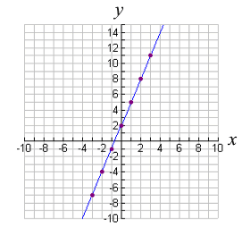
A $y=3x+2$

B $y=3x$

C $y=2x+2$

D $y=2x+3$
Answer: A

22.
(7.7A) Which equation best represents a relationship between x and y in the table below?

x | y
-4 | -11
-2 | -7
0 | -3
2 | 1
4 | 5

A $y=4x-3$

B $y=2x-3$

C $y=x-5$

D $y=-2x-3$
Answer: B
23.
(7.6G) In the bar graph below, what ratio of people surveyed own a dog?

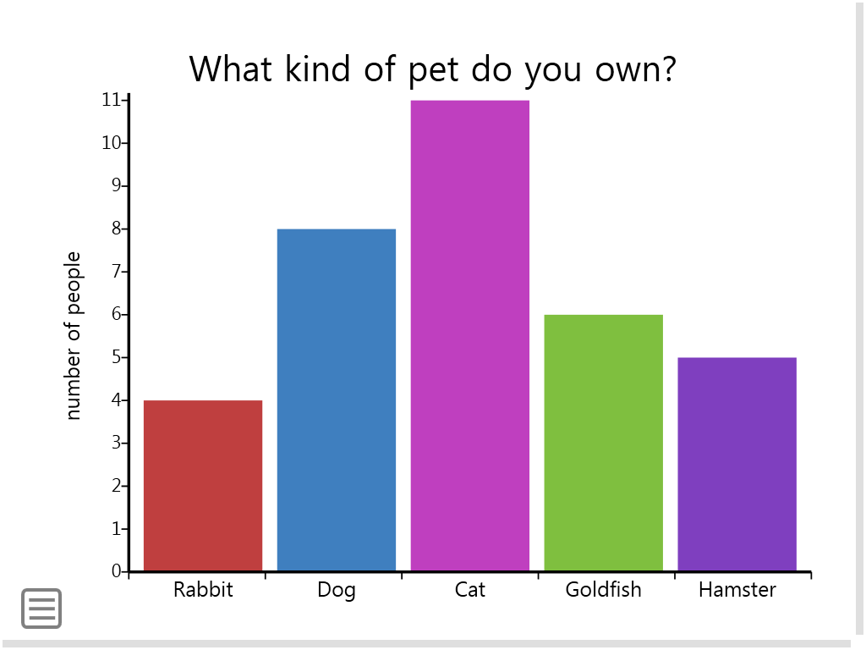
A 4/17

B 8/33

C 8/11

D 34/8
Answer: A

24.
(7.9A) A jewelry box is shaped like a rectangular prism. It has a length of 5 inches and height of 6 inches. Its volume is 315 cubic inches. What is the width of the jewelry box in inches?

Record your answer and fill in the bubbles on your answer document. Be sure to use the correct place value.

Answer: 10.5
25.
(7.11A) A newspaper has a classified section where people can pay to advertise items they want to sell. The paper charges 5 cents per character, plus a $4.00 fee per ad. The equation below can be used to determine m, the amount of money it costs to place an ad with c characters.

$$m=0.05c+4$$

If you spent $6.10 on an ad, how many characters did it have?

A 420

B 120

C 42

D 32
Answer: C

26.
(7.6G) In the circle graph below, what is the size of the central angle for the swimming sector?

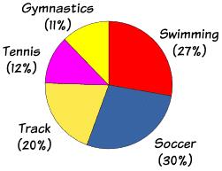

A 97.2$°$

B 87.2$°$

C 97.6$°$

D 95.4$°$
Answer: A

27.
(7.9B) Which of these is the closest to the area of a circle with a radius of 7 cm?

A 22 cm²

B 43.96 cm²

C 152 cm²

D 154 cm²
Answer: D

28.
(7.13C) Debra’s main financial assets are her home valued at $125,000, her savings account which has $30,000 in it, and her car valued at $10,000. For her liabilities, she has student loans totaling $25,000, and a credit card balance of $500. Based on these assets and liabilities, what is Debra’s net worth?

A $190,500

B $229,500

C $189,500

D $139,500
Answer: D

29.
(7.6D) Maria is rolling two 6-sided number cubes. What is the probability that she rolls two 5’s?

A 1/18

B 1/32

C 1/36

D 1/6
Answer: C

30.
(7.6C) The list below shows the number of earrings that Charlotte sold one day.

- Hoop earrings: 15
- Silver studs: 28
- Gold studs: 12
- Dangly earrings: 65

Based on these results, what is the most reasonable prediction of the number of stud earrings that will be sold out of the next 660 earrings sold?

A 154

B 66

C 220

D 165
Answer: C

31.
(7.9B) What is the circumference of a circle in inches with a radius of 3 inches? Use $π$ = 3.14.

Record your answer and fill in the bubbles on your answer document. Be sure to use the correct place value.

Answer: 18.84

32.
(7.6I) Two dice are tossed at the same time. One is four-sided and has different colors on each side: blue, green, yellow, red. The other is also four-sided and has the numbers 1,2,3,4. What is the probability of tossing the dice and they land on yellow and 4.

A 1/4

B 1/36

C 2/16

D 1/16
Answer: D

33.
(7.5B) For a circle with a diameter, d, radius, r, and circumference, C, which of the following expressions would describe $π?$

A $\frac{C}{r}$

B $\frac{C}{d}$

C $\frac{r}{C}$

D $\frac{d}{C}$
Answer: B

34.
(7.13E) Leslie is looking into interest bearing savings accounts. Bank A pays 10% in simple interest. Bank B also pays 10% but compounds the interest yearly. If Leslie invests $1000 of her money in the account for 2 years, what is the difference in the balance of each bank at the end of the 2 years?

A $200

B $1210

C $10

D $20
Answer: C

35.
(7.11B) Determine which of the given values would be a solution for the given inequality:

$9x-8≥$ 10

A -3

B -2

C 1

D 4
Answer: D

36.
(7.9C) What is the area of the composite figure below in square centimeters?

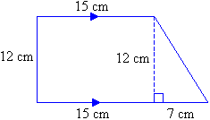

Record your answer and fill in the bubbles on your answer document. Be sure to use the correct place value.

Answer: 222

37.
(7.9D) Below is a square pyramid and its net. The height of the pyramid is 11.66 cm and the side length of the square base is 12 cm. Which of the following is the best approximation of the lateral surface area of the square pyramid?

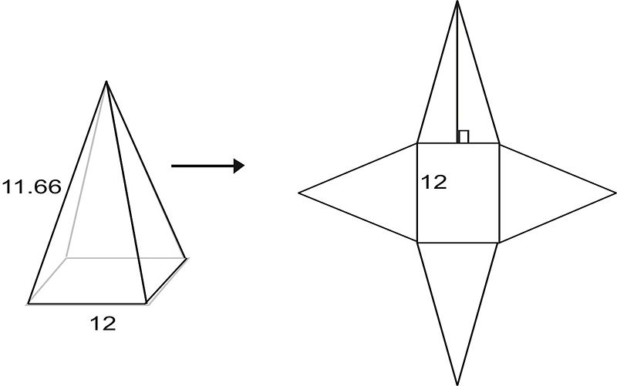
A 576 cm²

B 288 cm²

C 432 cm²

D 720 cm²
Answer: C

38.
(7.10A) Jared is buying 5 tickets to an amusement park and plans on spending $30.00 on food. He will spend a total of $85.00. Which equation represents this situation in order to solve for x, the price of one ticket?

A $30x+5=85$

B $5x-85=30$

C $5x+30=85$

D $x+30=85$
Answer: C

39.
(7.11A) A car mechanic charged $45.00 per hour plus $80 for parts. If the total bill was $417.50 without tax, then how many hours did the mechanic work on the car?

Record your answer and fill in the bubbles on your answer document. Be sure to use the correct place value.

Answer: 7.5

40.
(7.9A) Find the volume of the triangular pyramid below. All measurements shown are in inches.

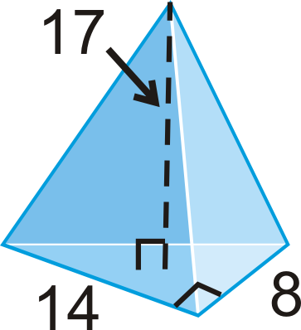
A 1904 in³

B 952 in³

C 634$\frac{2}{3}$ in³

D 317$\frac{1}{3}$ in³
Answer: D

41.
(7.12A) The store manager made box and whisker plots comparing the weekly sales in thousands for sales clerks Angela and Carl for the year 2014.

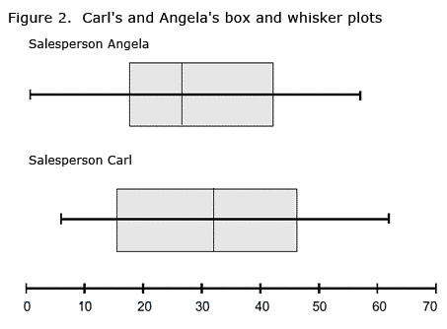
Based on the information in the box and whisker plots, which statement about their sales does NOT appear to be true?

A The respective ranges of Carl’s and Angela’s sales appear to be about the same.

B Carl’s median for weekly sales is greater than Angela’s median.

C Angela’s interquartile range is larger than Carl’s interquartile range.

D Carl’s maximum weekly sales amount is greater than Angela’s weekly sales amount.
Answer: C

42.
(7.3B) Malinda finds two pieces of gypsum, weighs them and records weights of 5$\frac{3}{4}$ grams and 4$\frac{1}{8}$ grams. Pat found a piece of gypsum and recorded the weight as 5.125 grams. What was the average weight of gypsum found?

A 15 grams

B 5 grams

C 5.5 grams

D 4.75 grams

Answer: B

43.
(7.10B) The number line below represents the solution to which one of the inequalities given?

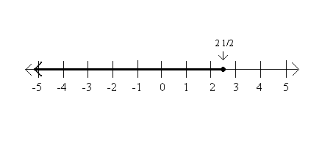
A $4x-20≤-10$

B $2x+6<11$

C $5x-4≥8.5$

D $x-6≤8.5$
Answer: A

44.
(7.10C) Which problem situation does the following equation best represent?
$4x+6=20$
A Joe bought 4 carnival tickets for x dollars each. He then bought 6 popcorns and spent a total of $20.00.

B Amy is a DJ at a radio station. During a 20 minute segment on her show, she needs to play 6 minutes of advertisements and four songs that are x minutes long each.

C It costs $4.00 for x people to go to a movie. If 6 more people go to the movies then it will cost $20.00

D Mary Ellen walks 4 miles an hour for x minutes. She then walks for 6 more minutes and walks for a total of 20 minutes.

Answer: B

45.
(7.13B) Martin makes $3000 a month. His rent is $550, his car payment is $225, and his spending on food is $400 per month. What percentage of Martin’s earnings is his car payment?

A 0.075%

B 7%

C 7.5%

D 8%
Answer: C

46.
(7.4E) Claire did her part of the science project using units of inches, and Tim did his measurements in centimeters. They decide to convert the inches to centimeters. There are about 2.54 centimeters in an inch. One of Claire’s measurements is 20 inches. What is this measurement in centimeters?

A 5.08 cm

B 7.9 cm

C 79 cm

D 50.8 cm
Answer: D

47.
(7.13D) In the city that Rhonda works in, she needs a minimum monthly household budget of $2500 per month to be able to pay all of her bills. If she works 40 hours per week for 50 weeks, what is the minimum amount that her hourly wage needs to be in order to earn at least $2500 per month?

A $15.00 per hour

B $62.50 per hour

C $12.50 per hour

D $7.25 per hour
Answer: A

48.
(7.4A) A baby increased in weight 12 ounces each month for the first year of his life. Which of the following is an equation that would represent the total weight, w, in pounds gained each month, m.

A $w=0.75m$

B $w=12m$

C $w=m+12$

D $m=0.75d$
Answer: A

49.
(7.13F) Dahlia finds a 15% off sale online for a stereo that normally sells for $99.00. There is no sales tax for online sales. She also found the same stereo in a local department store for $95.00 plus 6% tax. There is a $10 rebate for the stereo at the department store. Which is the better deal and why?

A The department store is the better deal because she gets to subtract $10.00.

B The online store is the better deal because she will save $6.55.

C The department store is the better deal because the stereo is less expensive to begin with and then there is a rebate also.

D The online store is the better deal because the stereo only costs $14.85.

Answer: B

50.
(7.11C) In a right triangle, one acute angle is 34$°$. What is the measure of the other acute angle?

A 66$°$

B 56$°$

C 90$°$

D 36$°$
Answer: B

