8th Grade Benchmark 1
(Chapters 1-9 of Math Explorations 2)

- (8.2A) The Venn Diagram below represents the relationships between the subsets of Real Numbers.
Real Numbers

Rational Numbers

Whole Numbers

Some of the subsets have not been labeled. What is the name of the subset of Real Numbers for the circle in the Venn Diagram that is standing alone?
A Integers
B Irrational Numbers
C Natural Numbers
D Imaginary Numbers

- (8.2A) Which subset of the Real Numbers includes fractions?
A Integers
B Irrational Numbers
C Rational Numbers
D Whole Numbers
3. (8.10B) In transformational geometry, which of the following transformations do NOT preserve congruence?
A Rotations
B Reflections
C Translations
D Dilations

4. (8.4C) The following table represents a linear relationship.
X | y
0 | -2
2 | 4
5 | 13
6 | 16
9 | 25

Which of the following choices represents the slope or rate of change of the relationship?
A -2
B 2
C 3
D 9

5. (8.2B) On a number line, between which two whole numbers would the $\sqrt{7}$ lie?
A Between 2 and 3
B Between 3 and 4
C Between 4 and 5
D Between 6 and 8

6. (8.5F) Which equation represents a proportional situation?
A $y=4x$
B $y=-3x-6$
C $y=x^{2}$
D $y=2x+5$
7. (8.9A) Determine the solution to the system of equations: $\left\{\begin{aligned}y=2x+1 \\ y=x+2\end{aligned}\right.$ It is graphed below.
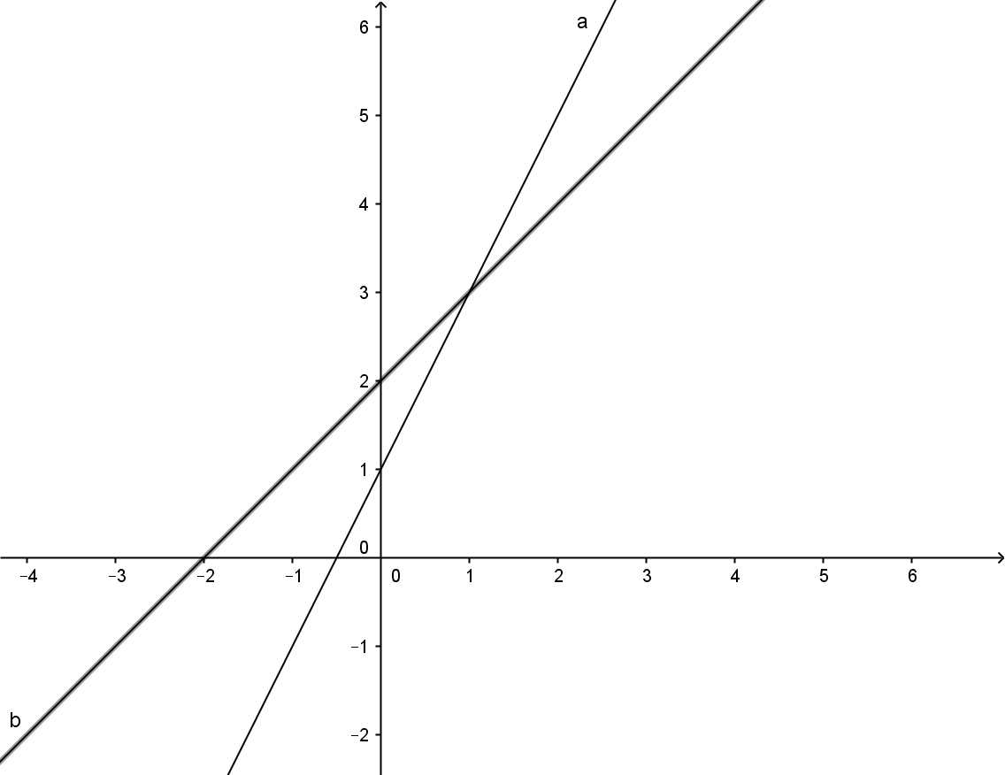

A $x=3$
B (1,3)
C (3,1)
D $x=1$

8. (8.5I) Clara is buying school supplies. She needs a graphing calculator which costs $89.00, and pocket folders at $0.15 each. If she buys x pocket folders and one graphing calculator, then which equation would represent the amount of money, y, that Clara spent?
A $x=0.15y+89$
B $y=89x+15$
C $y=89x+0.15x$
D $y=0.15x+89$

9. (8.2C) Mark’s calculator produced the following answer in scientific notation: $3.2×{10}^{-2}.$What is the standard notation equivalence to this answer?
A 0.32
B -0.032
C 320
D 0.032

10. (8.5A) Which set of ordered pairs represents the function represented in the mapping diagram below?

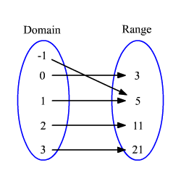
A {-1, 0, 1, 2, 3, 3, 5, 11, 21}
B {(-1, 3), (0, 3), (1, 5), (2, 11), (3, 21)}
C {(-1, 5), (0, 3), (1, 5), (2, 11), (3, 21)}
D {(3, -1), (3, 0), (5, 1), (11, 2), (21, 3)}

11. (8.10C) On a coordinate plane, point (a,b) is reflected across the x-axis. Which of the choices below represents the reflected point?
A (a,-b)
B (b, a)
C (-a, b)
D (-a, -b)

12. (8.5H) Which real-life situation can be represented by a proportional function?
A Harlon gets a monthly salary of $500 plus 2% commission on his sales.
B To convert temperature from Celsius to Fahrenheit, multiply the Celsius temperature by 1.8 and then add 32.
C Baby Evie started out at 21 inches long and then grew 1.5 inches per month for the first year.
D Shannon has a bunch of quarters. To find out how much money this equals, she will multiply the amount of quarters by 0.25.

13. (8.2D) Put the following set of numbers in order from least to greatest.
{$\sqrt{15}, -\frac{7}{2} , 4.1 , \frac{1}{3} , -3.2, 0.3 \}$
A {$-3.2, -\frac{7}{2} , \frac{1}{3} , 0.3, \sqrt{15}, 4.1\}$
B {$-\frac{7}{2} , -3.2, 0.3 , \frac{1}{3} , \sqrt{15}, 4.1 , \}$
C {$-3.2, -\frac{7}{2} , 0.3 , \frac{1}{3} , \sqrt{15}, 4.1 , \}$
D {$-\frac{7}{2} , -3.2, 0.3 , \frac{1}{3} , 4.1 , \sqrt{15} \}$

14. (8.2C) Convert 825,000,000 to scientific notation.
A $825×{10}^{6}$
B $8.25×{10}^{9}$
C $8.25×{10}^{8}$
D $8.25×{10}^{6}$

15. (8.10A) On a coordinate plane, point P, (-3,7), has been translated 5 right and 10 down. What are the coordinates of the translated point, P’?
A (-8, 17)
B (2, -3)
C (-13, 12)
D (2, -5)

16. (8.5A) The following graph can be represented as a linear proportional equation in the form of $y=kx.$

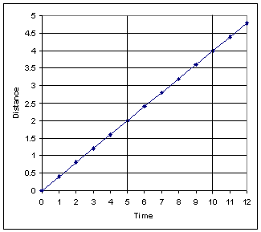
For this graph, what would be the value of k?
Record your answer and fill in the bubbles on the grid. Be sure to use the correct place value.
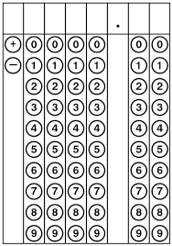

17. (8.2B) On a number line, between which two whole numbers would $\sqrt{215}$ lie?
A Between 13 and 14
B Between 14 and 15
C Between 53 and 54
D Between 107 and 108
18. (8.5B) The following graph represents a relationship between cost of gas, c, and distance, d, driven in kilometers. Which equation below represents this situation?
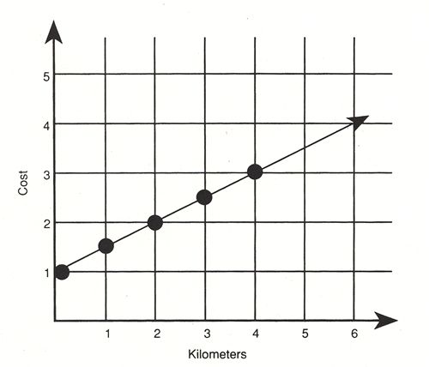
A $y=0.5x+1$
B $y=1.5x$
C $y=1.5x+1$
D $y=0.5x$

19. (8.10C) Marla used the following algebraic rule for her geometric transformations of two-dimensional shapes: All points, (x, y) were transformed using the rule ($x-12, y+8)$. Which choice describes the transformation that took place.
A x-values were reflected 12 units left, and y-values were reflected 8 units up.
B x-values were translated 12 units down, and y-values were translated 8 units right.
C x-values were translated 12 units left, and y-values were translated 8 units up
D x-values were dilated 12 units down, and y-values were dilated 8 units right.

20. (8.5G) Determine which of the following sets of ordered pairs does NOT represent a function.
A {(1,6), (2,6), (3,6), (4,6), (5,6)}
B {(-5,3), (-2,10), (0,1), (4,10), (18,3)}
C {(0,4), (5,2), (6,-6), (5,4), (7,2)}
D {(1,3), (2,6), (3,9), (4,12), (5,15)}
21. (8.4C) Use the data in the following table to determine the y-intercept of the function represented.
X | y
-6 | -16
-4 | -13
-2 | -10
0 | -7
2 | -4
4 | -1

Record your answer and fill in the bubbles on the grid. Be sure to use the correct place value.

22. (8.2D) Order this set of real numbers from greatest to least:{$\sqrt{27}, \sqrt{21}, 5, \frac{16}{3}, -6.21, -6.3\}$
A {$-6.3, -6.21, \sqrt{21,} 5, \sqrt{27}, \frac{16}{3}$ }
B {$\sqrt{27}, \frac{16}{3}, 5, \sqrt{21}, -6.21, -6.3 \}$
C {$-6.3, -6.21, \sqrt{21}, \sqrt{27}, 5, \frac{16}{3}$ }
D {$\frac{16}{3}, \sqrt{27}, 5, \sqrt{21}, -6.21, -6.3 \}$

23. (8.10A) Fiona plots the 3 points A(-3,5), B(2,6), and C(-5,-8) to form a triangle. She then reflects Triangle ABC over the y-axis to create Triangle AʹBʹCʹ. What are points Aʹ, Bʹ and Cʹ?
A Aʹ( 3,5 ), Bʹ(-2,6 ), Cʹ( 5,-8 )
B Aʹ( -3,-5 ), Bʹ(2, -6 ), Cʹ( -5,8 )
C Aʹ(5,-3 ), Bʹ(6,2 ), Cʹ(-8,-5 )
D Aʹ( 3, -5), Bʹ( -2, -6), Cʹ( 5,8 )
24. (8.5F) Which table represents a proportional relationship?
A B
x | y
-2 | -6
-1 | -3
0 | 0
1 | 3
2 | 6
x | y
-2 | 6
-1 | 7
0 | 8
1 | 9
2 | 10

C D
x | y
-4 | 0
-2 | 2
0 | 4
2 | 6
4 | 8
x | y
-6 | 36
-3 | 9
0 | 0
3 | 9
6 | 36

25. (8.5I) Which equation represents the data in the table below?
x | y
2 | 20
4 | 16
6 | 12
8 | 8
10 | 4

A $y=-2x+20$
B $y=-2x+24$
C $y=4x+24$
D $y=-4x+24$

Answers to 8th Grade Benchmark 1
- B
- C
- D
- C
- A
- A
- B
- D
- D
- C
- A
- D
- B
- C
- B
- 0.4
- B
- A
- C
- C
- -7
- D
- A
- A
- B

