The table shows the lengths of the radius and the areas of some circles.

**Area of Circles**

|  |  |  |  |  |  |  |
| --- | --- | --- | --- | --- | --- | --- |
| Length of  Radius (units) | 1 | 2 | 3 | 4 | 5 | r |
| Area  (square units) | π | 4 π | 9 π | 16 π | 25 π | A |

Find the area A of a circle with a radius r units long.

|  |  |
| --- | --- |
| A | A = π r2 |
| B | A = r2 |
| C | A = π r |
| D | A = 2 π r |

Answer: A

140°

40°

M

P

O

N

What kind of angle is ∠N ?

|  |  |
| --- | --- |
| A | Acute |
| B | Right |
| C | Obtuse |
| D | Straight |

Answer: A

In which of the pictures below does ∠P appear to be an obtuse angle?

|  |  |
| --- | --- |
| A | P |
| B |  |
| C | P |
| D | Answer: D  P |

An angle has a measure of 37 degrees. What is the measure of its complement?

|  |  |
| --- | --- |
| A | 90 degrees |
| B | 53 degrees |
| C | 143 degrees |
| D | 63 degrees |

Answer: B

An angle has a measure of 66 degrees. What is the measure of its supplement?

|  |  |
| --- | --- |
| A | 114 degrees |
| B | 24 degrees |
| C | 34 degrees |
| D | 246 degrees |

Answer: A

The supplement of an angle has a measure of 121º. What is the measure of the angle’s complement?

|  |  |
| --- | --- |
| A | 59º |
| B | 31º |
| C | 149º |
| D | 90º |

Answer: B

Which angle in this shape is obtuse? Trapezoid missing angles

|  |  |
| --- | --- |
| A | ∠A |
| B | ∠B |
| C | ∠ C |
| D | ∠D |

Answer: B

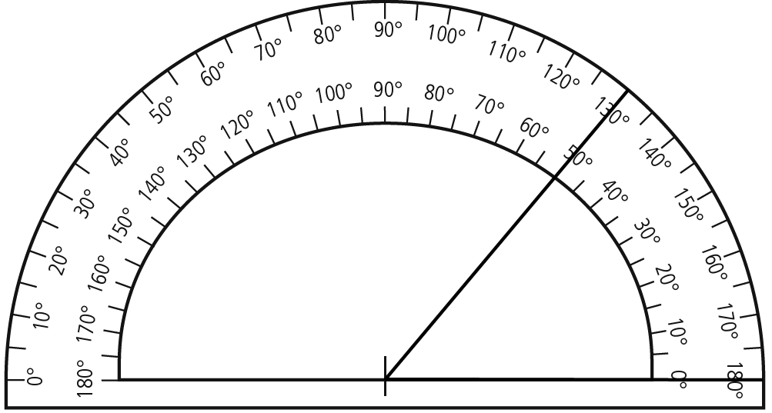What term describes the 50o angle?

|  |  |
| --- | --- |
| A | Acute |
| B | Right |
| C | Obtuse |
| D | Straight |

Answer: A

10) Each angle in this regular hexagon is

|  |  |
| --- | --- |
| A | Acute |
| B | Right |
| C | Obtuse |
| D | Straight |

Answer: C

Which of these best describes the angle formed by the top and right side of the picture frame?

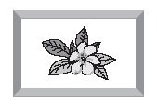

|  |  |
| --- | --- |
| A | Acute |
| B | Right |
| C | Obtuse |
| D | Straight |

Answer**:** B

The drawing to the right shows the shape of a plot of land.

**Plot of Land**

Z

130°

Find the measure of angle Z.

|  |  |
| --- | --- |
| A | 90o |
| B | 130o |
| C | 50o |
| D | 65o |

Answer: C

The obtuse angle in this isosceles triangle measures 140o.

What is the measure of  PRQ?

**P**

**R**

**Q**

|  |  |
| --- | --- |
| A | 140o |
| B | 130o |
| C | 40o |
| D | 20o |

Answer: D

Karen drew a 26 o angle and then used it as part of a right triangle. What are the

measures of the other two angles in Karen’s triangle?

|  |  |
| --- | --- |
| A | 180o; 0o |
| B | 130o; 50o |
| C | 90o ; 64o |
| D | 80o ; 64o |

Answer: C

Which of the following is a possible description of an obtuse triangle?

|  |  |
| --- | --- |
| A | 3 obtuse angles |
| B | 2 acute angles and 1 obtuse angle |
| C | 2 right angles and 1 obtuse angle |
| D | 2 obtuse angles and 1 acute angle |

Answer: B

A quilt pattern includes equilateral triangles like the one shown below.

What is the measure of each angle?

|  |  |
| --- | --- |
| A | 180o, 180o, 180o |
| B | 45o, 45o, 90o |
| C | 60o, 60o, 60o |
| D | 90o, 90o, 90o |

Answer: C

A planter is in the shape of a trapezoid with two congruent sides. Which expression

is equal to the measure of one of the top angles?

70°

70°

|  |  |
| --- | --- |
| A | 180º - (2  70º) |
| B | 360º - (2  70º) |
| C | (180º – 70º – 70º) ÷ 2 |
| D | 180º - 70º |

Answer: D

The drawing shows 2 circles that share a common

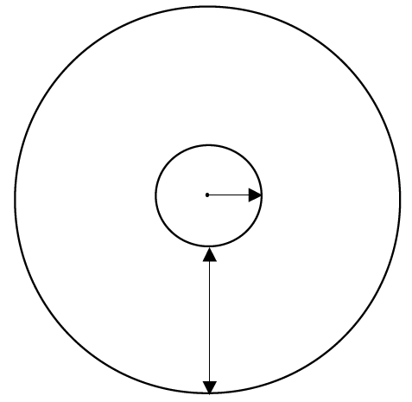

8 cm

3 cm

center point.

Which expression can be used to find the

approximate circumference of the outer circle

in centimeters?

|  |  |
| --- | --- |
| A | π  (3 + 8) |
| B | ½  ( 3 + 8) |
| C | 2 π (3 + 8) |
| D | 2  (3 + 8) |

Answer: C

If you know the distance around the Earth at the equator, how can you approximate the diameter of Earth?

|  |  |
| --- | --- |
| A | Multiply the distance by 3.14 |
| B | Divide the distance by 3.14 |
| C | Divide the distance by the radius |
| D | Divide the distance by the circumference |

Answer: B

Steven is practicing for a 10 K run, to be held in Austin, Texas. He ran one time around the outside of a circular track which was a distance of 5.5 miles. What is the **approximate** diameter of the track?

|  |  |
| --- | --- |
| A | about 1 mi |
| B | about 1.8 mi |
| C | about 6 mi |
| D | about 10 mi |

Answer: B

The handicapped symbol has a radius of 1.4 meters, and must

be present in parking lots to indicate handicapped parking spaces. About how tall is the symbol from top to bottom if you know the radius

is about 1.4 meters?

|  |  |
| --- | --- |
| A | 0.7 m |
| B | 1.5 m |
| C | 3.0 m |
| D | 4.5 m |

Answer: C

This lawn sprinkler can be adjusted so that the water stream is from 10 to 25 feet. What is the diameter of the largest circular area that this sprinkler will cover?

|  |  |
| --- | --- |
| A | 10 ft. |
| B | 20 ft. |
| C | 50 ft. |
| D | 80 ft. |

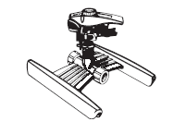

Answer: C

Which circle below would have a circumference that is about

twice the circumference of the circle to the right?

|  |  |
| --- | --- |
| A | 2 in. |
| B | 3 in. |
| C | 4 in. |
| D | 6 in. |

3 in.

Answer: B

If a box has two bases that have 6 sides each, what is the name of the shape?

A pentagonal prism

B hexagonal prism

C rectangular pyramid

D hexagonal pyramid

Answer: B

Find the height of a rectangular prism with a length of 3, a width of 3, and a volume of 27.

A 2

B 3

C 4

D 5

Answer: B