**6th Grade Benchmark 2**

**(Chapters 1-11 of Math Explorations 1)**

1. (6.7A)What is the value of the expression (9 – 4)2 5 – 3 X 4?

A -7

B -10

C 8

D -4

2. (6.3C) Jorge uses integer chips to determine the solution to an addition problem. A white circle represents +1, and a dark circle represents -1. Which equation does this integer chip problem represent?

○○○○○

+

●●●●●●●●

A

B

C

D

3. (6.5B) A class has 18 girls and 12 boys. The boys are what percent of the class?

|  |  |
| --- | --- |
| A | 12 % |
| B | 40 % |
| C | 30 % |
| D | 6 % |

4. (6.7C) The model below represents the equation 2*w* + 5 = *y* + 5.

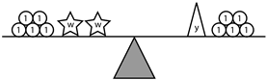

According to this representation, which of the following is true?

A *y* = 5

B *w* = 2*y*

C *y* = 2*w*

D2*w* + *y* = 10

5. (6.11A)Which of the following is true about segment MN?

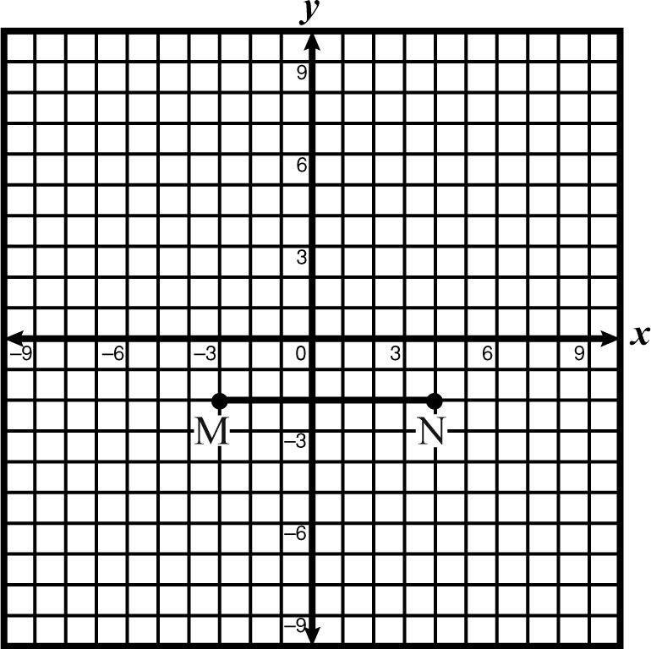

A (-2, 0) is a point on segment MN.

B All y-coordinates on segment MN are the same.

C (-2,-3) is a point on segment MN

DAll x-coordinates on segment MN are the same.

6. (6.2B) If *x* is a negative number then which of the following would be true?

A The absolute value of *x* and the opposite of *x* would be equal.

B The absolute value of *x* and the opposite of *x* would be opposite of each other.

C The absolute value of *x* would be greater than opposite of *x*.

D The absolute value of *x* would be less than the opposite of *x*.

7. (6.3D)Joe was on a game show in which for every question he answered correctly, the point value of the question was added to his score. If Joe answered the question incorrectly, the point value of the question was subtracted from his score. It is possible to have a negative score.

On Question 1, Joe answered a 200 point question correctly.

On Question 2, Joe answered a 150 point question incorrectly.

On Question 3, Joe answered a 400 point question incorrectly.

On Question 4, Joe answered a 150 point question correctly.

On Question 5, Joe answered a 50 point question correctly.

On Question 6, Joe answered a 250 point question incorrectly.

How many points did Joe have after Question 6?

Record your answer and fill in the bubbles on the grid. Be sure to use the correct place value.

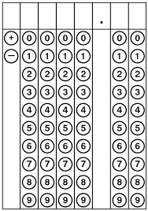

8. (6.6B) Josh is writing a book and has a goal of writing a certain amount of pages each day. Below is a table representing the total number of pages he has written dependent on the number of days he has been writing.

|  |  |
| --- | --- |
| Number of Days, *d* | Number of Pages, *p* |
| 2 | 15 |
| 4 | 30 |
| 6 | 45 |
| 8 | 60 |

Which equation represents the relationship between the independent and dependent quantities in the situation?

A

B

C

D

9. (6.2D) Kristi is practicing her freestyle stroke for the next swim meet. Her times were 48.4 seconds, 48.07 seconds, 47.8 seconds, and 48.46 seconds. Which list below shows her times in order from greatest to least?

|  |  |
| --- | --- |
| A | 48.07 s, 48.4 s, 48.46 s, 47.8s |
| B | 47.8 s, 48.4 s, 48.07 s, 48.46 s |
| C | 48.46 s, 48.4 s, 48.07 s, 47.8 s |
| D | 47.8 s, 48.07 s, 48.4 s, 48.46 s |

10. (6.8D) Find the volume in cm3 for a right rectangular prism with dimensions of height 3.2 cm, length of 4 cm and width of 6 cm.

Record your answer and fill in the bubbles on the grid. Be sure to use the correct place value.



11. (6.4B) Frogs are one of the best leapers! A frog can leap over 20 times its own length. (<http://allaboutfrogs.org>) Mina’s frog, Jupiter, competed in a frog jumping contest and Jupiter made a record leap of 125 inches. Assuming that Jupiter can leap exactly 20 times his own length, which of the following represent Jupiter’s length?

A 2500 inches

B 6 inches

C 1.25 inches

D 0.64 inches

12. (6.4G) Mary has 15 nickels, 10 dimes and 25 pennies. The nickels are what fraction of the total monetary value of her coins?

A

B 

C 

D 

13. (6.11A) Imagine that you are standing at the origin in a coordinate plane. You walk 10 units east, then 5 units north, then 2 units west. Which of the following points represent your position on the plane?

|  |  |
| --- | --- |
| A | (10, 5) |
| B | (8, 5) |
| C | (10, 2) |
| D | (2, 5) |

14. (6.3E) What is  of  ?

A 

B 

C 

D 

15. (6.6C) Jeff and Chad are each saving for a Philadelphia Eagles official jersey. Jeff is starting with $10 and plans on saving $6.00 per week. Chad has $15.00 and will start saving $9 per week. Let *c =* amount of money Chad saves each week, and *j* = amount of money Jeff saves each week. Which equation below represents an equation relating how much more Chad is saving each week compared to Jeff?

A

B

C

D

16. (6.4F) Which of the following choices represents the strip diagram below?

A 0.3

B 30%

C 3/10

D 33%

17. (6.11A) Determine the quadrant that contains the point (0.85, -2.08)

|  |  |
| --- | --- |
| A | Quadrant I |
| B | Quadrant II |
| C | Quadrant III |
| D | Quadrant IV |

18. (6.7C) Jack wrote several expressions to represent the fraction of the rectangle that is shaded in the figure below. Which is **NOT** an expression that he should have written?

|  |  |  |
| --- | --- | --- |
|  |  |  |
|  |  |  |
|  |  |  |
|  |  |  |
|  |  |  |

A

B

C

D

19. (6.10B) x + 5 = y. Find x if y is 7.

|  |  |
| --- | --- |
| A | x = 7 |
| B | x = 35 |
| C | x = 2 |
| D | x =12 |

20. (6.3D)What is the value of -4 + 2 • 3?

A 2

B -6

C -18

D 10

21. (6.2D) The table below shows the distances from Milton’s hotel in San Francisco to some places of interest in the city.

**Distances from Milton’s Hotel**

|  |  |
| --- | --- |
| **Places of**  **Interest** | **Distance** |
| Ghirardelli Square | km |
| Pier 39 | 0.8 km |
| China Town | 1600 meters |
| Union Square | 1.5 km |

Which of the lists below shows the places in order from least to greatest distance from Milton’s hotel?

A Ghirardelli Square, Pier 39, Union Square, China Town.

B Pier 39, Union Square, Ghirardelli Square, China Town.

C China Town, Union Square , Pier 39, Ghirardelli Square.

D China Town, Union Square, Ghirardelli Square, Pier 39

22. (6.4B) Mrs. Doubtfire’s local grocery store normally sells strawberries for $.03 per strawberry. She uses these strawberries to make her delicious strawberry jam. If it takes 200 strawberries to make 3 jars of jam, how much does it cost to make 5 jars of jam?

|  |  |
| --- | --- |
| A | $10 |
| B | $20 |
| C | $5 |
| D | $15 |

23. (6.3E) Lorne bought an apple pie and ate  of the pie. He decided to distribute the remaining pie equally among his three cats Moe, Larry, and Curly. What fraction of the whole pie will each cat receive?

A 

B 

C 

D 

24. (6.8D) Mr. Wooster has a rectangular farm that is  of a mile long and  of a mile wide. Which of the following represent the area of Mr. Wooster’s farm?

|  |  |
| --- | --- |
| A | Area = mi2 |
| B | Area = mi2 |
| C | Area = mi2 |
| D | Area = 2mi2 |

25. (6.4C) In Ms. Dearth’s algebra class, twenty-four percent of the students won a notebook in a math contest at the school fair. Which of the following represents the ratio of the students who won a notebook to those who did not win a notebook?

|  |  |
| --- | --- |
| A | or 24 : 100 |
| B | or 6 : 25 |
| C | or 76 : 24 |
| D | or 6 : 19 |

26. (6.5A) If , find x.

|  |  |
| --- | --- |
| A | x = 22 |
| B | x = |
| C | x = 16 |
| D | x = |

27. (6.4B) If it takes 6 apples to make 5 apple pies, how many apples does it take to make 15 apple pies?

|  |  |
| --- | --- |
| A | 12 |
| B | 9 |
| C | 36 |
| D | 18 |

28. (6.4H) Juan is going on a road trip with his family from San Marcos, TX to Denver, CO. His mom, Marie, is driving the car at 30 mph. How many feet does Juan’s family travel in one minute based on the given speed? (1 mile = 5280 feet)

|  |  |
| --- | --- |
| A | 2640 feet |
| B | 316800 feet |
| C | 5280 feet |
| D | 0.5 feet |

29. (6.8D) Mr. Lemen is planning his vegetable garden. The garden will measure 14 feet by 16 feet, and he wants to plant tomatoes in $\frac{1}{3}$ of the garden. Mr. Lemen is also planning to plant new hybrid tomatoes in $\frac{1}{4}$ of the area that he has designated for tomatoes. Which method will **NOT** help Mr. Lemen find the area that has been designated for the hybrid tomatoes?

A Find the area of the garden and multiply that product by $\frac{1}{12}$.

B Find the product of $\frac{1}{3}$ and $\frac{1}{4}$ and multiply it by the area of the garden.

C Find $\frac{1}{3}$ the area of the garden and then multiply that product by $\frac{1}{4}$.

D Find the area of the garden and multiply by .

30. (6.5A) Mr. Williams notices he needs gas for his car. If his tank holds 16 gallons and it cost him $64.75 to fill up his tank, about how much did he pay for a gallon of gasoline?

|  |  |
| --- | --- |
| A | $2 |
| B | $3 |
| C | $4 |
| D | $5 |
|  |  |

31. (6.3C) Which number line correctly models –4 + 3?

A

B

C

D

D

-8

-7

-5

-6

-4

-3

-2

-1

0

1

2

3

5

4

6

7

8

-8

-7

-5

-6

-4

-3

-2

-1

0

1

2

3

5

4

6

7

8

-8

-7

-5

-6

-4

-3

-2

-1

0

1

2

3

5

4

6

7

8

-8

-7

-5

-6

-4

-3

-2

-1

0

1

2

3

5

4

6

7

8

32. (6.12C) During a grading period a student has the following quiz scores:

85, 95, 70, 65, 80, 85

What is the mean for this data?

Record your answer and fill in the bubbles on the grid. Be sure to use the correct place value.



33. (6.8A) The following choices show lengths of different line segments. Which is the only choice in which the three line segments could form a triangle?

A AB = 5 in, BC = 1 in, CA = 3 in

B AB = 4 in, BC = 2 in, CA = 2 in

C AB = 2 ½ in, BC = 3 ½ in, CA = 6 in

D AB = 3 in, BC = 5 in, CA = 7 ½ in

34. (6.5A) It is 35.5 miles from Kristen’s house to the lake house. She found this distance on the state road map to be 5 centimeters. How many miles does 1 centimeter represent on the state road map?

|  |  |
| --- | --- |
| A | 7 miles |
| B | 7.1 miles |
| C | 5 miles |
| D | 5.5 miles |

Questions 35 – 37 refer to the following information:

A teacher shows her class the scores on a midterm exam in the stem-and-leaf plot:  
 4 | 5 8 8  
 5 | 0 1 1 3 6 7 7 9  
 6 | 1 2 2 3 3 3 4 6 7 7 7 7 8 9  
 7 | 0 1 1 2 3 4 4 5 8

35. Identify the number of students in the class.

A 32

B 34

C 36

D 38

36. Identify the mode.

A 4

B 7

C 67

D 78

37. What is the median of the scores?

A 62.5

B 63

C 63.5

D 64

38. (6.14D) It is important for a person to establish a positive credit history. Which of the following statements is **NOT** a benefit of having a positive credit history?

A A high credit score makes it easier to get a credit card.

B A high credit score can qualify a person for lower interest rates on loans.

C A high credit score helps people to qualify for a house or car loan.

D A high credit score will qualify you for a college scholarship.

39. (6.9A) Polly has started a chocolate chip cookie business. She advertises that each of her cookies will have at least 3 more chocolate chips inside than any of her competitor’s cookies. If $p=number of chips in Polly^{'}s cookies$ and $c=number of chips in the competitor^{'}s cookies$, which statement below represents Polly’s claim?

A

B

C

D

40. (6.3B) If *x* is a positive number, which of the following expressions represent a quantity that is greater than *x*?

A

B

C

D

41. (6.2A) The Venn Diagram below represents the relationships between the subsets of rational numbers.

Natural Numbers

Whole Numbers

Integers

Rational Numbers

What is the only number that is inside the Whole Number circle, but not inside the Natural (or Counting) Numbers circle?

A -1

B 0

C

D 1

42. (6.5C) Melissa is reading a book and has completed 180 pages of the 300 page book. Which value does NOT represent the portion of the book yet to be read?

A 40%

B 0.4

C

D

43. (6.4A) Which of the following equations represents the graph below?

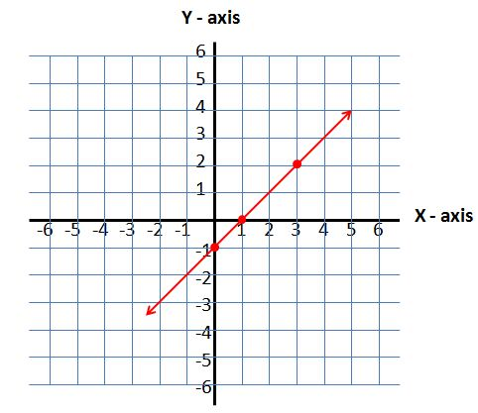

A

B

C

D

44. (6.4D) Nathan’s Hot Dog Eating Contest is held every year on July 4th on Coney Island. The first winner in 1972 was Jason Schechter who ate 14 hot dogs in 3 $\frac{1}{2}$ minutes. Takeru Kobayashi shattered all previous records in 2001 almost doubling the amount of hot dogs ever eaten in one sitting by gobbling down 50 hot dogs in 12 minutes. As of 2015, Joey Chestnut holds the current world record by consuming 69 hot dogs in 10 minutes. The women’s world record is held by Sonya Thomas for 45 hot dogs in 10 minutes. Which of the rates below is NOT equivalent to any of the rates discussed above? (https://en.wikipedia.org/wiki/Nathan%27s_Hot_Dog_Eating_Contest)

A

B

C

D

45. (6.6A) Shirley is saving $6.00 each month to her savings account and makes the following graph to represent her total savings each month.

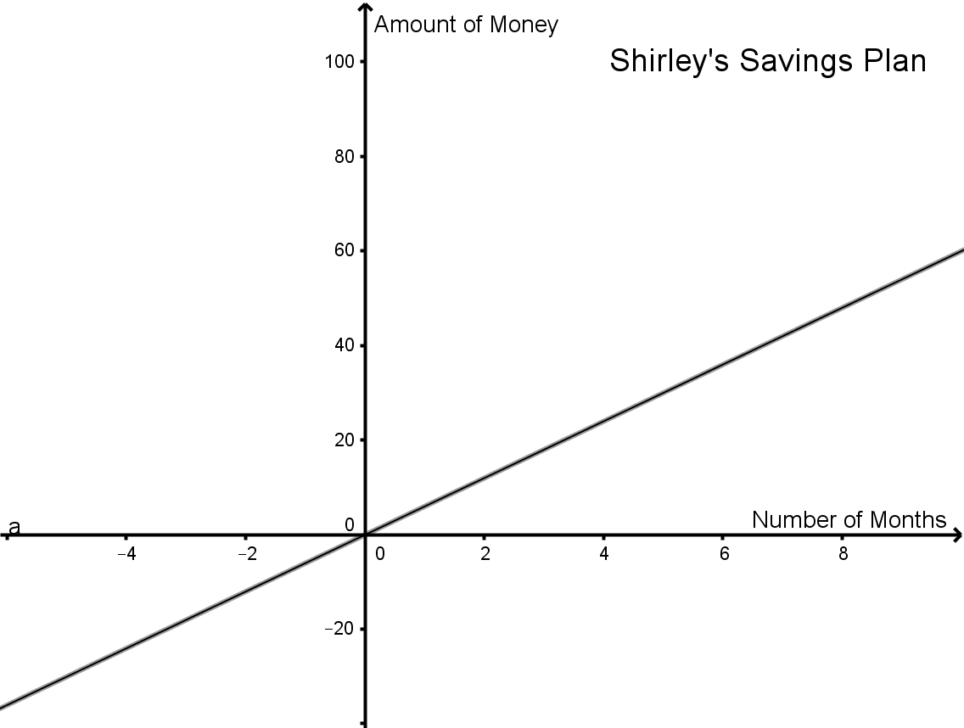

Here are some possible statements about the graph:

I The axis labeled “Number of Months” represents the independent variable.

II The axis labeled “Amount of Money” represents the independent variable.

III The “Number of Months” depends on the “Amount of Money.”

IV The “Amount of Money” depends on the “Number of Months.”

Which of the following statements is true about the above graph?

A I and III

B I and IV

C II and III

D II and IV

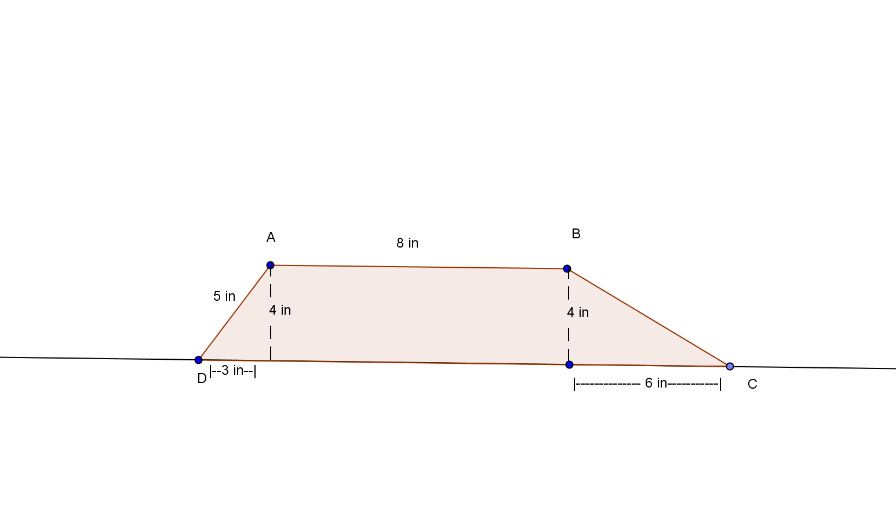

46. (6.8B) In Trapezoid ABCD, segment AB is parallel to segment DC. Which of the following does **NOT** model a formula for the area of Trapezoid ABCD below?

A $A=17∙4-\frac{1}{2}\left(3\right)\left(4\right)-\frac{1}{2}(4)(6)$

B $A=\frac{1}{2}(8+17)∙4$

C $A=5∙8+\frac{1}{2}\left(4\right)\left(6\right)$

D $A=8∙4+\frac{1}{2}\left(3\right)\left(4\right)+\frac{1}{2}(4)(6)$ Answer: C

47. (6.9B) Which of the following number lines represents the solution to the inequality $-2x>8$?

A

-5 -4 -3

B

-5 -4 -3

C

-5 -4 -3

D

-5 -4 -3

48. (6.9C) Which real-world problem below is represented by the equation $10=x+4.5?$

A When Marcus was born he weighed 10 pounds and three weeks later he had gained 4.5 pounds. What is *x*, the amount he weighed at three weeks old?

B Marcus needs $10 to go to the circus. He has $4.50. What is *x*, the amount of money Marcus lacks to be able to go to the circus?

C Marcus is canning peach preserves. He currently has ten jars completed and needs to add 4.5 more. What is *x*, the total amount of peach preserves Marcus wants to can?

D Marcus is selling cars and has 4 ½ more days to make his quota of 10 cars. What is *x*, the number of additional cars Marcus needs to sell?

49. (6.12) A forest ranger is measuring the heights of new trees in a section of a forest that burned the previous year. The heights in inches are as follows:

6, 15, 9, 6.5, 6, 29, 22, 18, 12.5, 7, 23, 3, 14, 13, 5, 17

The forest ranger wants to make a histogram with the x-axis representing the heights of the trees in inches and the y-axis representing the frequency of trees occurring in each height interval. Which scale interval should the ranger choose for the x-axis?

A The x-axis should be scaled by 1’s.

B The x-axis should be scaled by 2’s.

C The x-axis should be scaled by 6’s.

D The x-axis should be scaled by 16’s.

50. (6.14C) Li started with $950.00 as the balance of her checking account. She then made the following transactions.

|  |  |  |  |  |
| --- | --- | --- | --- | --- |
| Date | Transaction | Payment/Debit | Deposit/Credit | Balance |
| 3/1 |  |  |  | $950.00 |
| 3/2 | Grocery Store | $35.15 |  |  |
| 3/3 | Pay Check |  | $250.00 |  |
| 3/4 | Apartment Rental | $550.00 |  |  |
| 3/5 | Electric Bill | $122.34 |  |  |

What will be Li’s new balance after the transactions are made? Record your answer and fill in the bubbles on the grid. Be sure to use the correct place value.



**Answer Key for 6th Grade Benchmark 2**

1. A 26. B
2. B 27. D
3. B 28. A
4. C 29. D
5. B 30. C
6. A 31. D
7. -400 32. 80
8. A 33. D
9. C 34. B
10. 76.8 35. B
11. B 36. C
12. C 37. C
13. B 38. D
14. A 39. A
15. C 40. A
16. D 41. B
17. D 42. C
18. C 43. D
19. C 44. C
20. A 45. B
21. A 46. C
22. A 47. B
23. B 48. B
24. A 49. C
25. D 50. 492.51