**8th Grade Benchmark 2**

**(Chapters 1-13 of Math Explorations 2)**

1. (8.5B) Which equation represents the data in the table below?

|  |  |
| --- | --- |
| *x* | *y* |
| 1 | -1 |
| 2 | 2 |
| 3 | 5 |
| 4 | 8 |
| 5 | 11 |

A $y=3x-4$

B $y=-4x+3$

C $y=3x-1$

D $y=3x-3$

1. (8.8C) Solve this equation for *x.*

4(*x $-$* 15) = 2x $–$ 130

Record your answer and fill in the bubbles on the grid. Be sure to use the correct place value.

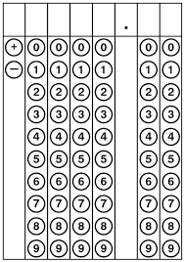

3. (8.3A) If a 5-inch by 7-inch photograph is enlarged by a scale factor of , what will be its new dimensions?

A 8 in. by 10in.

B 10 in. by 14 in.

C 12.5 in. by 17.5 in.

D 2 in. by 2.8 in.

4. (8.5A) If there are approximately 2.54 centimeters in every inch, which formula could be used to calculate *c*, the number of centimeters in *x*  inches?

1. *x* = 2.45*c*
2. *c* = 2.54 *x*
3. *c* = 
4. **

5. (8.5I) A trash company charges a fee of $80 to haul off a load of trash. There is also a charge of $0.05 per mile the load must be hauled. Which equation can be used to find c, the cost for hauling a load of trash *m* miles?

A *c* = 80(*m*+0.05)

B *c* = 0.05(*m*+80)

C *c* = 80m+ 0.05

D *c* = 0.05*m*+80

6. (8.5C) Which graph below would best represent the relationship between *x*, the length of a diameter, and *y*, the circumference of a circle?

|  |  |  |  |
| --- | --- | --- | --- |
| **A** |  | **C** |  |
|  |  |  |  |
| **B** |  | **D** |  |

7. (8.6B) The picture below shows a cylinder and a cone each having the same height and radius. If the cylinder has a volume of 366 cm3, then what is the volume of the cone?

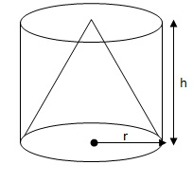

A 91.5 cm3

B 122 cm3

C 183 cm3

D 244 cm3

8. (8.10A) A triangle ABC has coordinates of A(­3, 6), B (4, 2) and C(1, ­3). The triangle is translated 5 units to the right and 3 units down. What will be the coordinates of A'B'C'?

A Aʹ(-8, 3), Bʹ(-1, -1), Cʹ(-4, -6)

B Aʹ(5, 3), Bʹ(9, -1), Cʹ(-4, 0)

C Aʹ(2, 3), Bʹ(9, -1), Cʹ(6, -6)

D Aʹ(2, 3), Bʹ(-1, -1), Cʹ(6, -6)

9. (8.12D) Fred wants to invest some money and is comparing banks. He wants to invest $10,000 for 20 years. He found two banks who will each pay 6% interest on his investment. The only difference is that Bank A only pays simple interest, and Bank B compounds the interest monthly. How much more does Bank B end up paying at the end of the 20 years compared to Bank A?

A $12,000

B $33,102.04

C $21,102.04

D $11,102.04

10. (8.9A) Determine the value of *x* for this system of equations: $\left\{\begin{aligned}4x-6y=-4 \\ 8x+2y=48\end{aligned}\right.$

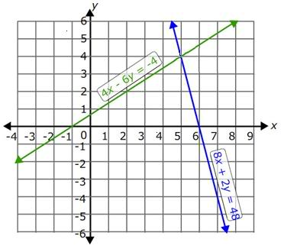

Record your answer and fill in the bubbles on the grid. Be sure to use the correct place value.



11. (8.2C) The thickness of a butterfly wing is 0.00035 centimeters. ([www.mathsaccelerator.com](http://www.mathsaccelerator.com)). What is this measurement in scientific notation?

A $3.5×{10}^{4}$ cm

B $3.5×{10}^{-5 }$ cm

C cm

D cm

12. (8.11A) Lamar conducted an experiment in which he surveyed 100 students and recorded how many hours they spent studying for a test the day before, and the subsequent test score the next day. A scatter plot of the data is below. Which choice below best describes the correlation of the test scores and time spent studying?

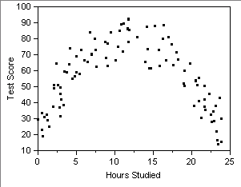

A The data exhibited a non-linear correlation.

B The data exhibited a positive linear correlation.

C The data exhibited a negative linear correlation.

D The data exhibited no correlation or association.

13. (8.6A) Which of the choices below best describes how to find the volume of a cylinder?

A Multiply length times width times height.

B Multiply the radius squared times the height.

C Multiply the circumference of the cylinder to its height and then add to that the areas of the top and bottom of the cylinder.

D Multiply the area of the base to the height of the cylinder.

14. (8.6C) Below is a diagram that models the use of Pythagorean Theorem. If the area of the smallest square is 25 in2 and the area of the medium-sized square is 36 in2, then what is the area of the largest square in inches squared?

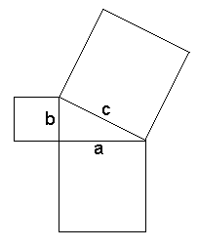

Record your answer and fill in the bubbles on the grid. Be sure to use the correct place value.



15. (8.5E) The total cost of hot sauce varies directly with the number of bottles of hot sauce you buy. If you buy 5 bottles of hot sauce for $4.89, then how much does 7 bottles cost?

A $6.79

B $6.84

C $6.85

D $6.86

16. (8.3C) Triangle ABC has been dilated with the origin as the center of the dilation to form Triangle AʹBʹCʹ. Which of the following algebraic rules represents the dilation?

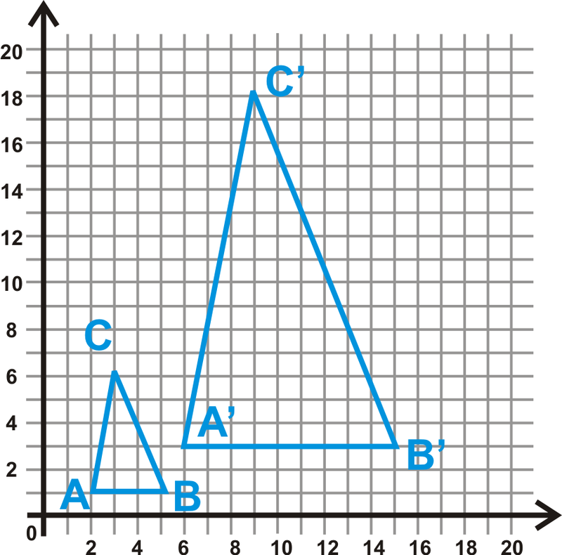

A (2*x*, 2*y*)

B (2.5*x,* 2.5*y*)

C (3*x*, 3*y*)

D (9*x,* 9*y*)

17. (8.7C) In the rectangle below, $\overline{AB}=5 cm$ and $\overline{AD}=2 cm.$ What is the length of diagonal $\overline{AC}$?

A B

D C

A

B

C

D 29

18. (8.2A) The Venn diagram below represents the set of Real Numbers.

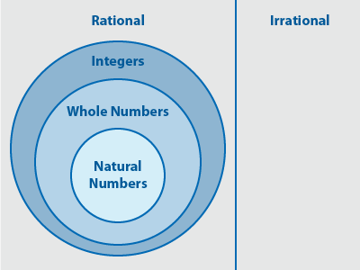

To which subset(s) of the Real Numbers does the number 2 belong?

A Natural Numbers only

B Natural Numbers and Whole Numbers

C Natural Numbers, Whole Numbers, Integers and Rational

D Natural Numbers, Whole Numbers, Integers, Rational and Irrational

19. (8.8A) Matt’s carpets are filthy so he decides to rent a carpet cleaning machine. Company *Looks Like New* charges a $50.00 deposit and $12.00 per hour for the use of their machine. Company *Stains-R-Us* charges a $75.00 deposit and $8.00 per hour for the use of their machine. Letting the number of hours equal *h*, write an equation that would allow you to solve for the number of hours in which both companies would cost the same amount.

A

B

C

D

20. (8.7D) What is the shortest distance between the points (-3,2) and (5,-5)?

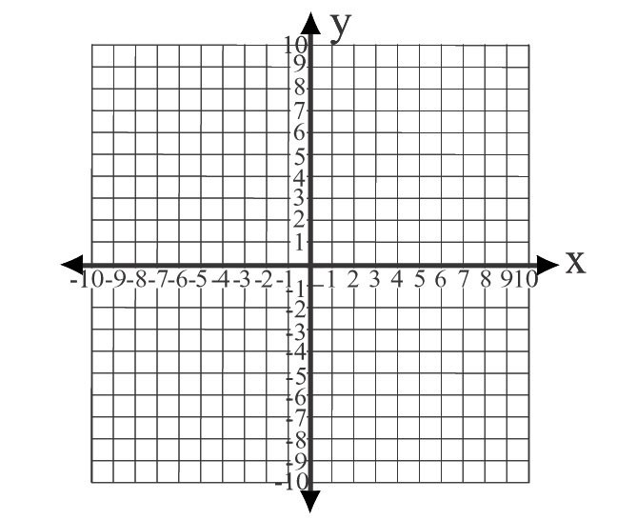

A $\sqrt{30}$

B 15

C 78

D

21. (8.12C) When Hunter was born, his parents invested $12,000 in an account for college that earned 8.9% interest compounded yearly. How much money was in the account at the end of 18 years, and what is the mathematics behind the growth?

A $13,068.00 which comes from 12,000 $+ 12,000 ∙0.089$

B $19224.00 which comes from 12,000(0.089)(18)

C $31224.00 which comes from 12,000 + 12,000(0.089)(18)

D $55677.93 which comes from 12,000(1.089)18

22. (8.4A) In the figure below, points A, M and B all lie on the same line. What is the slope of $\overline{AM}$?

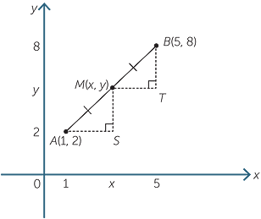

A

B

C 2

D 3

23. (8.10D) A trapezoid that has an area of 52 square cm has been dilated by a factor of 3. What is the area of the dilated trapezoid?

A 468 cm2

B 156 cm2

C 312 cm2

D 624 cm2

24. (8.7B) Some tag board is cut, folded and taped to form a rectangular prism. What is the total surface area for this rectangular prism as shown below?

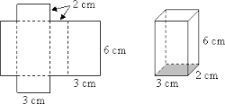

A 36 cm3

B 36 cm2

C 60 cm2

D 72 cm2

25. (8.8D) In the figure below, two parallel lines, *m* and *n* are cut by a transversal, *t*. Which of the following choices is **NOT** correct?

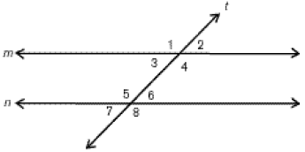

A

B

C

D

26. (8.10C) The following points were graphed on a coordinate plane: (7, 10), (4,9), (6.4, -3), and (-2, 0.5). If the rule (-*x, y*) was applied to each of the points, what kind of transformation would this accomplish?

A Rotation of 90° counter-clockwise

B Reflection over the *y*-axis.

C Rotation of 180°

D Rotation of 270° counter-clockwise

27. (8.2B) Which of the following points on the number line below is closest to $\sqrt{191}$?

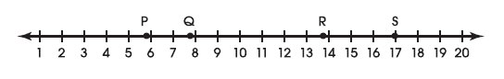

A Point P

B Point Q

C Point R

D Point S

28. (8.5F) Which equation represents a proportional function?

A

B

C

D

29. (8.7A) A sphere has a diameter of 12 inches. What is the volume of the sphere?

A 288 in3

B 2304 π in3

C 48 π in3

D 288 π in3

30. (8.3B) Triangle ABC was dilated to form Triangle AʹBʹCʹ. Which of the following statements is **NOT** true in relation to a comparison of the attributes of a shape and its dilation on a coordinate plane?

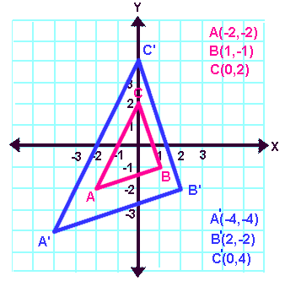

A Triangle ABC is similar to Triangle AʹBʹCʹ.

B The corresponding angles of the two similar triangles are equal.

C The corresponding sides of the two similar triangles are proportional.

D The area of Triangle AʹBʹCʹ is 2 times the area of Triangle ABC.

31. (8.2D) Place the following set of real numbers in order from least to greatest.

{, }

A }

B }

C }

D }

32. (8.4C) The following table represents a linear relationship.

|  |  |
| --- | --- |
| *x* | *y* |
| -2 | 9 |
| 0 | 8 |
| 2 | 7 |
| 4 | 6 |
| 6 | 5 |

What is the slope of the line represented in this table? Record your answer and fill in the bubbles on the grid. Be sure to use the correct place value.



33. (8.8B) Which of the following real-world situations would correspond with the following inequality? $0.04x+50>0.03x+60$

A The cellular phone company, *More than Just Talk,* charges a $50 monthly fee and 4 cents per minute for use of streaming capabilities. Its competitor, *Call It,* charges a $60 monthly fee and 3 cents per minute for use of streaming capabilities. At how many minutes is *More than Just Talk* more expensive than *Call It?*

B Taylor gets a 4% commission on sales plus a $50.00 gas allowance each week. Morgan gets a 3% commission on sales plus a $60.00 gas allowance each week. For what amount of sales does Morgan make more money than Taylor?

C Elvia takes 50 minutes to do laundry and 4 minutes per piece of clothing to iron the clothes. Maxine takes 60 minutes to do laundry and 3 minutes per piece of clothing for ironing. For how many pieces of clothing does Elvia take longer than Maxine?

D Flower shop, *Blooms*, charges $50.00 for a basic arrangement and will add 4 balloons for a dollar. Flower shop, *Petals,* charges $60.00 for a basic arrangement and will add 3 balloons for a dollar. For how many balloons will *Blooms* cost more than *Petals*?

34. (8.4B) At Jack’s farm, for every 5 hens there are 2 roosters. What is the slope of the line graphed if the number of hens is on the *y-*axis and the number of roosters is on the *x*-axis?

A 0.4

B 2.5

C 5

D 2

35. (8.5D) The following graph shows the relationship between a driver’s age and the distance from which a driver is able to read a sign. Each point represents a driver. Even though none of the drivers surveyed were 60 years old, use the trend line to predict the sign legibility distance in feet for a 60-year old driver.

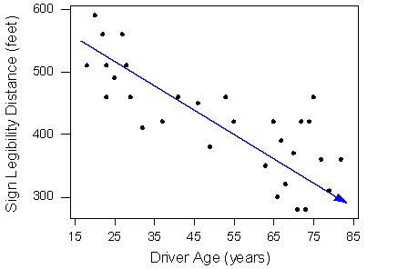

A 320 feet

B 350 feet

C 390 feet

D 420 feet

36. (8.11B) Eight students were comparing how many Facebook friends they had. Find the average distance between each data value and the mean by finding the mean absolute deviation for the number of Facebook friends. The table of data for the 8 students is shown below.

|  |  |  |  |
| --- | --- | --- | --- |
| Number of Facebook Friends | | | |
| 88 | 28 | 130 | 450 |
| 152 | 225 | 330 | 101 |

A 0

B 110.25

C 188

D 882

37. (8.5I) Identify the function represented in this graph.

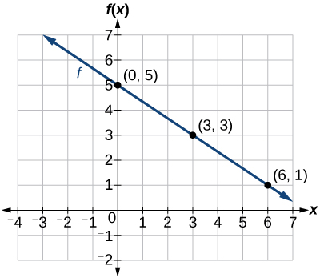

A

B

C

D

38. (8.3C) Which of the following algebraic rules would dilate a 2-dimensional figure on a coordinate plane by a scale factor of 6 using the origin as the center of dilation?

A (*6x, y*)

B (*3x, 3y*)

C (*x, 6y*)

D (*6x, 6y*)

39. (8.10B) For a two-dimensional shape graphed on a coordinate plane, which is the only transformation that would change the area of the shape?

A Dilation

B Translation

C Rotation

D Reflection

40. (8.5H) Below are two examples of functions that arise from real-world situations.

I Lupe bought 18 shares of a stock on the stock market valued at *x* dollars a share. Let *y* be the total amount of money that Lupe paid for the stock.

II Magdalena bought 15 shares of a stock valued at *x* dollars a share plus had to pay a broker fee of $30.00. Let *y* be the total amount of money that Magdalena paid for the stock including the broker fee.

Identify each of the situations as being proportional or non-proportional. Select the choice that applies.

A Situation I and Situation II are both proportional situations.

B Situation I and Situation II are both non-proportional situations.

C Situation I is proportional and Situation II is non-proportional.

D Situation I is non-proportional and Situation II is proportional.

41. (8.2D) A group of surveyors have used indirect methods to estimate the distance across a river. The following are their individual estimates in meters. Place them in order from greatest to least.

$\frac{32}{3}$, 10.5, $\sqrt{113}$, 4 $\sqrt{7}$

A 10.5, $\sqrt{113}$, $4\sqrt{7}$, $\frac{32}{3}$

B $\frac{32}{3}$, 10.5, $\sqrt{113}$, $4\sqrt{7}$

C 10.5, , ,

D , , , 10.5

42. (8.5G) Identify the function represented in the following set of ordered pairs.

{(-2,15), (0,10), (2,5), (4,0), (6,-5)}

A

B

C

D

43. (8.8C) Solve the equation for *x*: $1.3x-5=3.7x+3.4$

Record your answer and fill in the bubbles on the grid. Be sure to use the correct place value.



44. (8.4C) Mark has been paying off a loan and made a graph of his progress. Determine the slope, *m*, and y-intercept, *b*, for this graph.

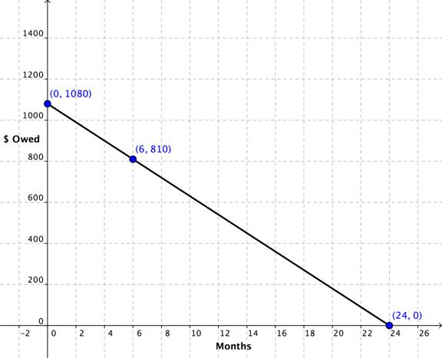

A *m* = -45; *b* = 1080

B *m* = 270; *b* = 24

C *m* = -270; *b* = 1080

D *m* = -45; *b* = 0

45. (8.7A) The cone below has a height, *h,*  of 8 inches, a radius, r, of 6 inches and a slant height, *l*, of 10 inches. What is the volume of the cone in terms of ?

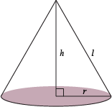

A 96 in3

B 288 in3

C 96 in3

D 120 3

46. (8.5D) A school nurse measured the height and weight of 70 children and a scatter plot was created. By use of a trend line and some extrapolation, the nurse predicted what the average weight would be for a child measuring 50 inches. Which of the choices below would be the best prediction?

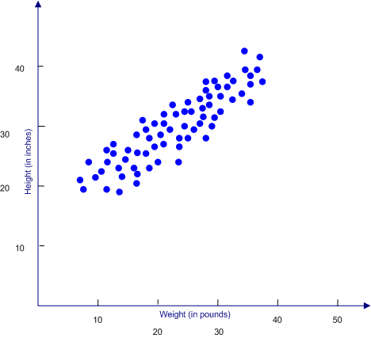

A 40 inches

B 44 inches

C 48 inches

D 58 inches

47. (8.7C) Four students each drew a triangle. The table below shows the dimensions of each triangle.

|  |  |  |  |
| --- | --- | --- | --- |
| Student | Leg 1 length (cm) | Leg 2 length (cm) | Hypotenuse length (cm) |
| Abby | 6 | 1 | $$\sqrt{37}$$ |
| Bruce | 4 | 5 | 6 |
| Calli | 9 | 5 | $$\sqrt{106}$$ |
| Delores | 5 | 12 | 13 |

Which student did **NOT** draw a right triangle?

A Abby

B Bruce

C Calli

D Delores

48. (8.10C) Doris wants to rotate rectangle ABCD 180 $°$ counter-clockwise. Which of the algebraic rules below should she use?

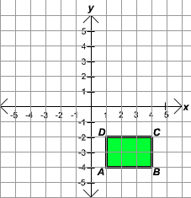

A ()

B ()

C ()

D (

49. (8.5G) Which of the following tables does NOT represent a function?

A B

|  |  |
| --- | --- |
| *x* | *y* |
| 1 | 0 |
| 2 | 2 |
| 3 | 4 |
| 4 | 6 |
| 5 | 8 |

|  |  |
| --- | --- |
| *x* | *y* |
| -2 | 4 |
| -1 | 1 |
| 0 | 0 |
| 1 | 1 |
| 2 | 4 |

C D

|  |  |
| --- | --- |
| *x* | *y* |
| 1 | 5 |
| 3 | 5 |
| 7 | 5 |
| 9 | 5 |
| 20 | 5 |

|  |  |
| --- | --- |
| *x* | *y* |
| 2 | 5 |
| 1 | 4 |
| 0 | 3 |
| 1 | 2 |
| 2 | 1 |

50. (8.7B) A cylinder and its net are represented below. The height of the cylinder is 6 cm and the radius is 2 cm. What is the surface area of the cylinder rounded to the nearest tenth?

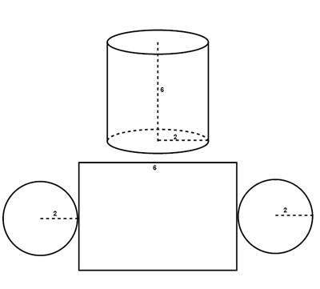

A 100.5 cm2

B 88.0 cm2

C 75.4 cm2

D 62.8 cm2

**Answer Key for 8th grade Benchmark 2**

1. A 26. B
2. -35 27. C
3. C 28. B
4. B 29. D
5. D 30. D
6. A 31. A
7. B 32. -0.5
8. C 33. A
9. D 34. B
10. 5 35. C
11. D 36. B
12. A 37. A
13. D 38. D
14. 61 39. A
15. C 40. C
16. C 41. D
17. B 42. B
18. C 43. -3.5
19. A 44. A
20. D 45. C
21. D 46. C
22. B 47. B
23. A 48. B
24. D 49. D
25. C 50. A