Additional Problems for 7th Grade Benchmark 1

AP1
(7.7A) Which equation best represents the relationship between x and y below?

x | y
0 | -7
3 | -5
6 | -3
9 | -1
12 | 1
A $y=2x-7$

B $y=\frac{x}{3}-7$

C $y=-2x-7$

D $y=\frac{2}{3}x-7$
Answer: D

AP2
(7.7A) A pool has 2 feet of water in it, and water is being added to it at a rate of 3 inches per hour. Which equation represents the relationship between y, the height of the water in inches, and x, the number of hours water is being added?

A $y=3x+2$

B $y=3x+24$

C $y=2x+3$

D $y=2+\frac{3}{x}$
Answer: B

AP3
(7.10A) Monique needs $6.00 in quarters for a coin-operated washing machine. She already has five quarters. Which equation can be used to find x, the number of additional quarters Monique needs in order to have enough money to wash her clothes?

A $0.25x+1.25=6$

B $1.25+x=6$

C $x-6=30$

D $1.25x+6=30$

Answer: A

AP4
(7.11A) A 50-gallon tank is draining at a rate of 2.5 gallons per minute. Model an equation to represent the time, t, in minutes it will take the tank to only have two gallons left in it. Solve for t.

- $2+2.5t=50; t=18 minutes$

- $2.50+2t=50; t=23.75 minutes$

- $50-2.5t=2; t=19.2 minutes$

- $50-2.5t=2; t=20 minutes$
Answer: C

AP5
(7.11A) Tickets for a play cost $5.00 each and40 tickets have already been sold. Model an inequality to represent the number of additional tickets, x, that need to be sold in order for the play revenue to be at least $1200. Solve the inequality.

A $40+5x≥1200; x≥232 tickets$

B $5x+200≥1200; x≥200 tickets$

C $40+5x≤1200; x≤232 tickets$

D $5x+200<1200; x<200 tickets$
Answer: B

AP6
(7.2A) Which subset of the rational numbers would best describe the type of numbers in the following set:

$\left\{-18, -13,-7, 0, 2, 315\right\}$

- Whole Numbers

- Integers

- Natural Numbers

- Negative Numbers

Answer: B

AP7
(7.2A) Which of the following statements is true?

- Whole Numbers is a subset of the Integers.

- Integers is a subset of the Whole Numbers.

- The set of Whole Numbers contains all of the Integers.

- All Integers are contained in the set of negative Whole Numbers.

Answer: A

AP8
(7.4A) Which of the following equations represents the distance, d, a car travels if it is moving at 55 miles per hour? Let t represent the number of hours the car has been traveling.

- $d=55+t$

- $t=55+t$

- $d=55t$

- $t=55d$
Answer: C

AP9
(7.4C) Which of the following equations has a constant of proportionality of 7?

A. $y=7x+5$

B. $y=5x+7$

C. $y=7$

D. $y=7x$
Answer: D

AP10
(7.4C) What would be the constant of proportionality for the following table?
x | y
0 | 0
1 | 4.5
2 | 9
3 | 13.5
4 | 18

- 0

- 4.5

- 9

- 18

Answer: B

AP11
(7.10B) The following number line represents the solution for which inequality? 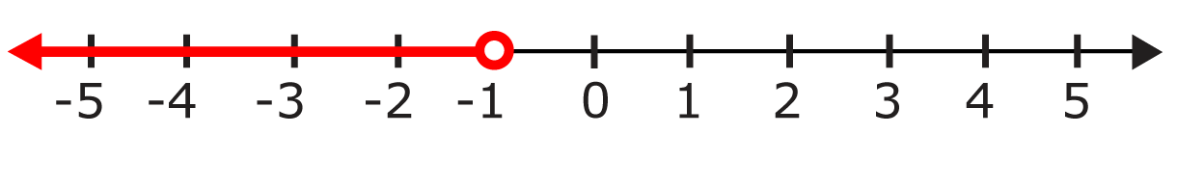
A $-3x+5<8$

B $3x+10≤13$

C $x+4>3$

D $3x+6<3$

Answer: D

AP12
(7.10B) The following number line represents the solution for which inequality?

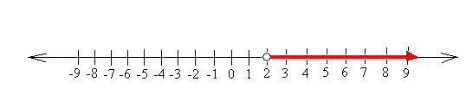

A $3x+4>10$

B $4x-5≥3$

C $2x+4<2$

D $12>6x$

