Test Bank Questions by TEKS for Chapter 1

6.2(C)

1. What temperature does the thermometer show? (The thermometer is scaled by 2˚.)
A | -8˚ C
B | -2˚ C
C | 2˚ C
D | 8˚ C
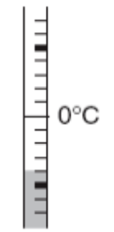

Answer: A

6.3(C)

2. The Dallas Cowboys had the football on their own 45 yard line. During their next play, they lost 8 yards. Which integer represents the change in the position of the football?
A | 37
B | 8
C | -8
D | -37

Answer: C

3. Every week Susan earns $150 working at the bookstore after school. When she gets paid, she deposits $50 in her savings account at the bank. Which integer represents one of Susan’s deposits?

A | -150
B | -50
C | 50
D | 150

Answer: C

4. Which of these amounts could best be represented by the integer -175?

A | The depth in feet to which a marine biologist dove.
B | The number of new people who bought a club membership.
C | The distance in feet a geologist ascended up the wall of a canyon.
D | The amount of dollars a store received from a company for a computer modem.

Answer: A

6.3(D)

5. Sam is on a rock climbing trip in Mystic Valley. He camps on the valley floor, which is 130 feet below sea level, and spends each day climbing the valley walls. One day he climbs 75 feet and stops for a break. After the break, Sam continues to climb upward for another 18 feet and then 21 feet more. What is Sam’s elevation above or below sea level (in feet)?

A | 93 feet below sea level
B | 16 feet above sea level
C | 114 feet above sea level
D | 16 feet below sea level

Answer: D

For questions 6-9, use the figure below.
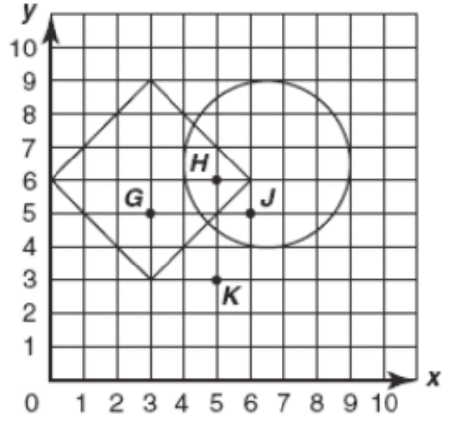

6.11(A)

6. Which point is located at the coordinate pair (3, 5)?

A | Point G
B | Point H
C | Point J
D | Point K

Answer: A
6.11(A)

7. Which of these ordered pairs is inside the circle but not inside the square?

A | (3, 5)
B | (5, 3)
C | (5, 6)
D | (6, 5)

Answer: D

6.11(A)

8. Which ordered pair represents a point located inside both the square and the circle?
A | (3, 5)
B | (5, 3)
C | (5, 6)
D | (6, 5)

Answer: C

6.11(A)

9. Which ordered pair is NOT in the square nor in the circle?

A | (3, 5)
B | (5, 3)
C | (5, 6)
D | (6, 5)

Answer: B
6.11(A)

10. Which ordered pair shows the location of point L?
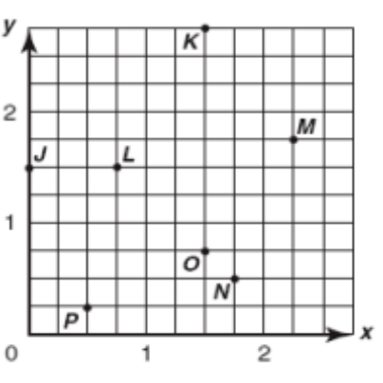

A | 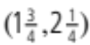
B | 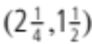
C | 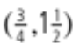
D | 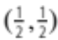

Answer: C

6.3(C)

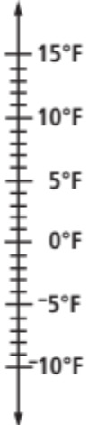
11. At noon the temperature was 4˚ F. By sunset the temperature had dropped 8˚. What was the temperature at sunset?

A | -8˚ F
B | -4˚ F
C | 4˚ F
D | 8˚ F

Answer: B

6.3(D)

12. The temperature at noon on Monday is 7˚ C. Readings are taken every six hours and show a drop of 3˚, a drop of 2˚, a drop of 6˚ and a rise of 8˚. What is the temperature at noon on Tuesday?

A | -8˚ C
B | -4˚ C
C | 4˚ C
D | 8˚ C

Answer: C

6.11(A)

13. A number line could represent which of the following:

A | X- axis only
B | Y- axis only
C | Either X or Y axis
D | Neither axis

Answer: C

6.2(A)

14. Given the set of values {7, 13, -1, 0, -5, 11, -15, 4, 6, -3, -7, 8} select and list, in increasing order, all of the values that belong to:

a. the set of natural numbers

b. the set of negative integers

c. the set of integers greater than -6 and less than 5

d. the set of whole numbers less than 10

Answer:
a. {4, 6, 7, 8, 11, 13} b. {-15, -7, -5, -3, -1}
c. {-5, -3, -1, 0, 4} d. {0, 4, 6, 7, 8}

6.11(A)

15. Plot and label the following points on the given coordinate system:

a. (0, 4) b. (-3, 0) c. (1, -2) d. (4, 4) e. (-3, -4) f. (-4, 2)

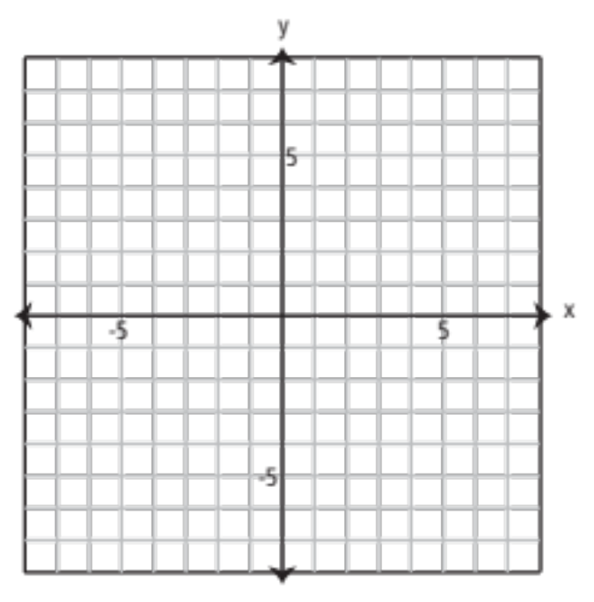

Answer:

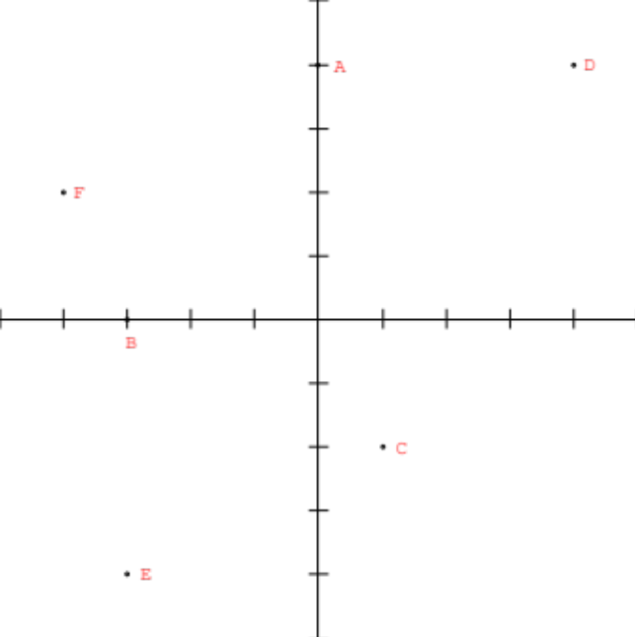

6.11(A)

16. Draw a coordinate plane and plot the following points.

a. (0,0) b. (0, -4) c. (-6, 0)
d. (-3, -4) e. (-2, -2) f. (-3, 3)
Answer: Make sure students label their graphs and have all 6 points.

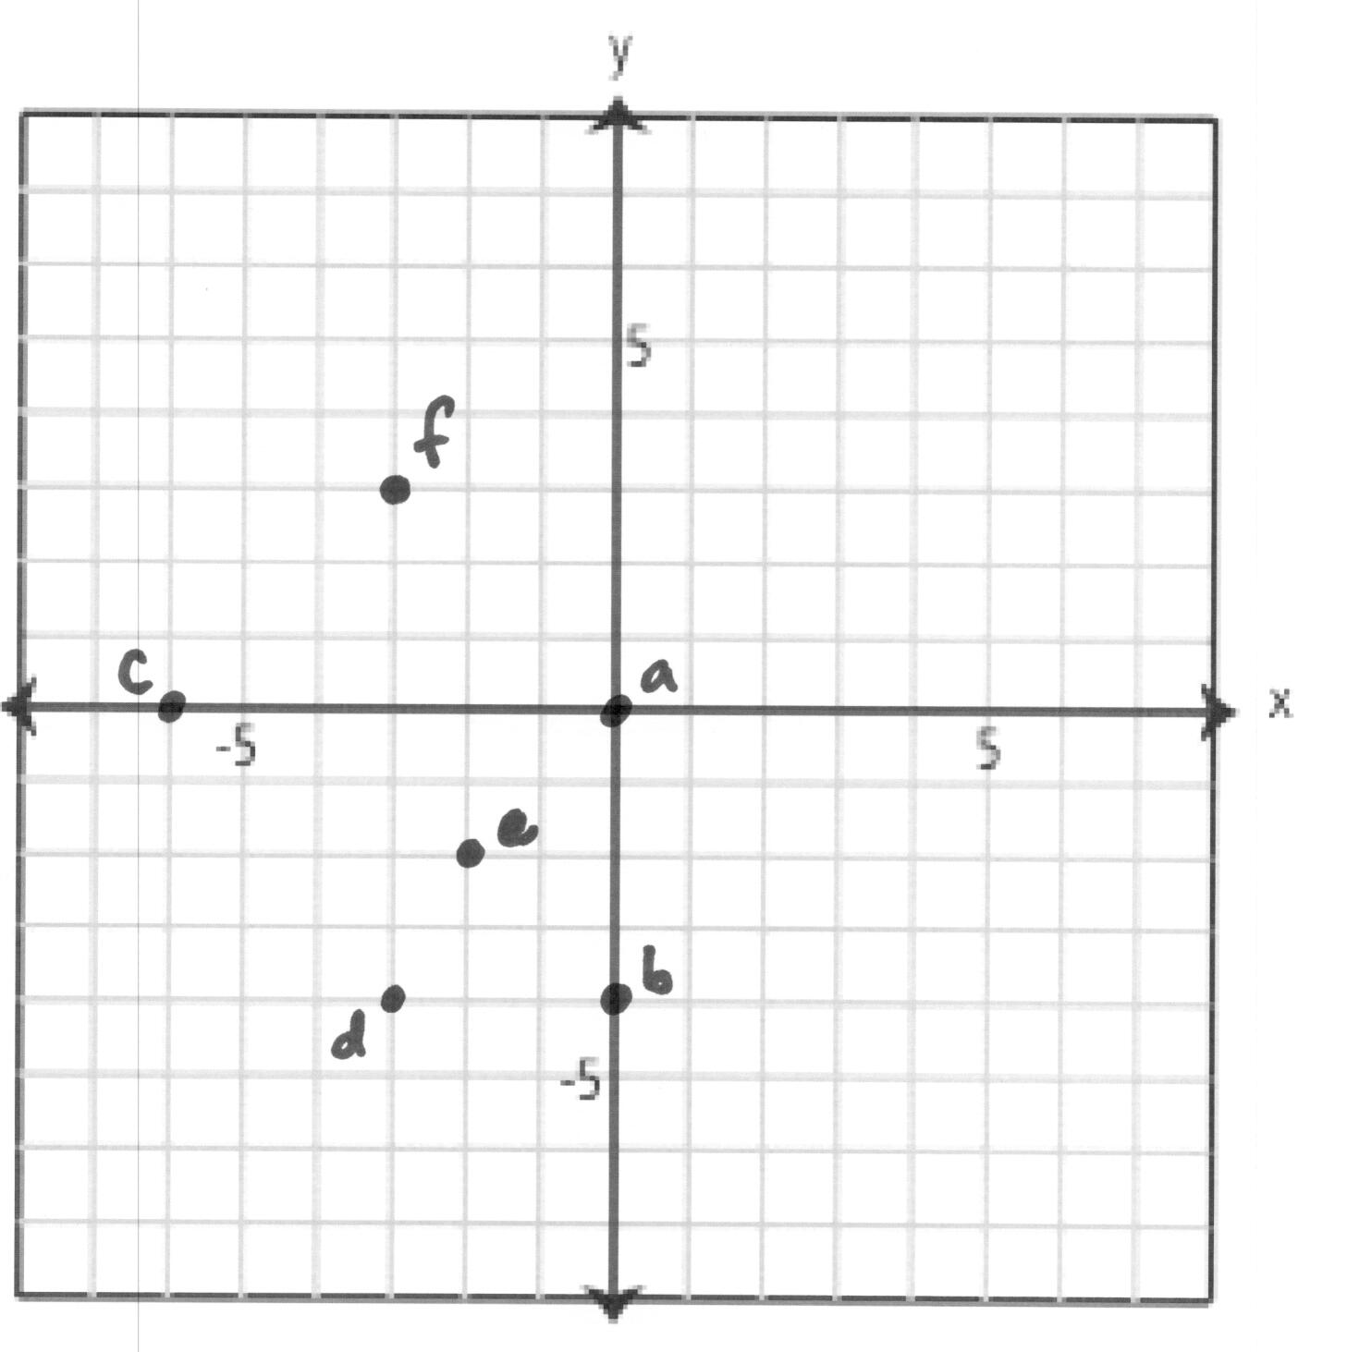

6.11(A)

17. Plot the following points as specified on the coordinate plane.

a. A point in the first quadrant.
b. A point in the second quadrant.
c. A point in the third quadrant.
d. A point in the fourth quadrant.

Answers may vary. There should not be any points on the axes.

6.3C

18. Find the distance between each pair of integers on a number line:

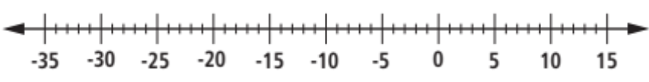

a. 1 and 15 b. -2 and -7 c. -31 and -33
d. 5 and -11 e. -22 and -14

Answer:
a. 14 b. 5 c. 2 d. 16 e. 8

6.3(C)

19. Draw a number line and label the point at -7 as A, the point at -2 as B, the point at 4 as C and the point at 9 as D, then answer the following

a. What is the distance from A to D?
b. What is the coordinate of the point three units to the right of B?
c. What is the coordinate of the point 12 units to the left of D?
d. What is the distance from B to C?

Answer:
check for appropriate scale and range
a. 16 b. 1
c. -3 d. 6

6.3(C)

20. Answer the following:

- Draw a number line by choosing an appropriate scale and label the points on the number line so that its end points are at -200 and 200.

b. Label the origin as O, -40 as A, -120 as B, 160 as C and 70 as D.
c. What is the distance from A to D?
d. What is the coordinate of the point 30 units to the right of B?
e. What is the coordinate of the point 25 units to the left of D?
f. What is the coordinate of the point midway between A and C?

Answer:
a. check for appropriate scale and range
b. check students’ work (Left to right: B, A, O, D, C at -120, -40, 0, 70, 160)
c. 110
d. -90
e. 45
f. 60

6.2(D)

21. Insert either < , = , or > in each blank to produce a true statement.

a. -3 __ 4 b. 7 __ -13 c. -2 __ -6
d. 31 __ -31 e. -15 __ -1 f. 8 __ 45
g. 15 __ 15 h. -15 __ 15 i. -1 __ 0

Answer:
a. -3 < 4 b. 7 > -13 c. -2 > -6
d. 31 > -31 e. -15 < -1 f. 8 < 45
g. 15 = 15 h. -15 < 15 i. -1 < 0

6.3(D)

22. At noon the temperature is 4˚ C. Four hours later the temperature is -11˚ C. By how many degrees did the temperature decrease?

Answer: 15˚

6.11(A)

23. Plot four lattice points so that each has a y-coordinate that is one less than its x-coordinate. Include at least one point in the third quadrant.

Answer:
Answers may vary. The students can choose any whole number points along the line y = x – 1, making sure that they have 4 points and at least one in the third quadrant.

6.2(C)

24. Given two numbers 7 and -8, answer the following:

a. Which number is greater?
b. Find a number to the left of -8. Is this number less than or greater than -8?
c. Find a number to the right of -8. Is this number less than or greater than -8?
d. Find an integer between -8 and 7

Answer:
a. 7
b. answers may vary, -9 is one possiblity; it is less than -8
c. -7, answers may vary; it is greater than -8
d. any one of the following: -7, -6, -5, -4, -3, -2, -1, 0, 1, 2, 3, 4, 5, or 6

6.7(B)

25. Translate the following into a mathematical expression.

a. 5 more than R
b. 8 less than T
c. 5 more than 6
d. X less than 3

Answer:
a. R + 5 or 5 + R b. T – 8 c. 6 + 5 or 5 + 6 d. 3 – X

6.7(B)

26. Translate each into a mathematical expression or inequality.

a. P is less than 10
b. P less than 10

Answer:
a. P < 10 b. 10 - P
6.1(F) BONUS

27. Calculate the sum 1 + 2 + 3 + … + 5. Now calculate the sum 1 + 2 + 3 + … + 9 + 10. Can you think of a way to calculate the sum of n natural numbers? (Hint: Look for patterns)

Answer:
1 + 2 + 3 + … + 5 = 15, 1 + 2 + 3 + … + 9 + 10 = 55

Answers may vary on the third part. The algebraic method is [n (n+1)]/2 which most 6th graders cannot construct on their own. They should be looking for patterns such as the following. If the outside numbers are added together, then the next two most outer numbers, etc. you’ll have multiples of the first sum. For example in the second calculation above, there are 5 multiples of the sum 11, so 5 times 11 is 55. Another possibility is to get multiples of 10, then add the left over pieces. Let the students draw out and explain their solutions.

