CHAPTER 3: Modeling Problems Algebraically

VOCABULARY

A. Expression | B. Variable | C. Equation | D. Evaluate
E. Subtraction  Property of Equality | F. Equivalent | G. Addition  Property of Equality

_______ 1. A letter or symbol that represents a number.

_______ 2. A term used to describe things in mathematics that are equal to each other or have the
same value.
_______ 3. When subtracting the same amount from both sides of an equation, the resulting quantities are
equal.
_______ 4. A mathematical phrase like “ m + 1” used to describe quantities mathematically.

_______ 5. A math sentence with an equality sign between two expressions.

_______ 6. When adding the same amount to both sides of an equation, equality is preserved.

_______ 7. To find the value of an expression by replacing the variables with numbers.

8. What problem does the model show?

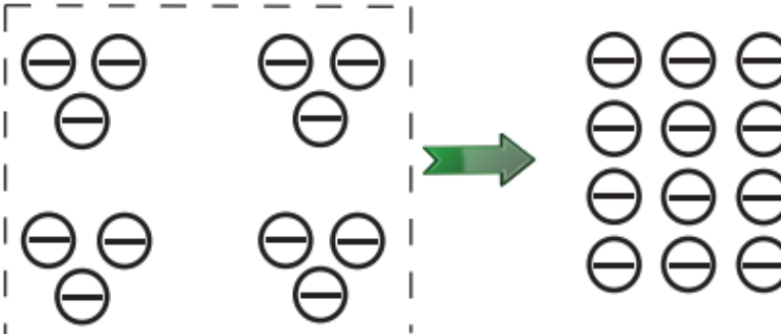

a. Stephanie had 4 cookies. Her friend gave her 3 more. How many cookies does she have in all?
b. Bob gave 3 crayons to each of his 4 friends. How many crayons did he give away?
c. Kirsti gave 4 dollars to each of her three friends. How many dollars does she have now?
d. Molly had 4 extra notebooks in her desk. She gave 3 of them to Susan. How many extra notebooks does she now have?

9. Which expression does the model show?
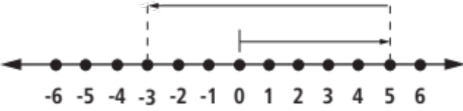

a. 8 + 5 b. -5 + 8 c. 8 – 5 d. 5 – 8

10. What is the first step in solving for x in the equation below?
x + 6 – 4 = -3
a. add 4 to 3 b. subtract 3 from 6 c. subtract 4 from 6 d. add 6 to 3
11. Scott is digging a new flower bed in his grandmother’s yard. The
bed is 2 feet wide by 9 feet long. How many feet of fencing will Scott need to
buy to go around the new flower bed?

a. 11 b. 18 c. 22 d. 44
12. Which problem situation does the following equation best represent?
x = 13 - 2 (7)
a. Gretchen measured how long it took to ride her bike from home to school,
a distance of 7 miles. What is x, the amount of time it will take for her to
ride her bike 13 miles?
b. Terry bought movie tickets for $7.00 each. What is x, the number of
tickets that can be purchased for exactly $13.00?
c. Sally purchased two shirts that cost $13.00. What is x, the amount of
change she received from $7.00?
d. David bought two books for $7.00 each, including tax. He gave the clerk
$13.00. What is x, the amount of change David received?

Solve the following equations:

13. x = -27 + 16

14. 34 – m = -2

15. 21 = y + 8

16. a – 14 = -3 + 2

17. 5 – 17 + b = 9 – 4

18. By how much does the sum 12 + 23 + 34 + 45 + 56 + 67 + 78 + 89 exceed the sum
13 + 24 + 35 + 46 + 57 + 68 + 79?

a. 8 b. 12 c. 82 d. 102

19. Of the whole numbers 5, 18, 64, 101 and 127, how many are greater than the sum of their digitis?
a. 2 b. 3 c. 4 d. 5

20. The legendary singer Frank Sinatra was born on December 12, 1915. If Sinatra was still alive, how old would he be today?

21. Susan had $22 in her pocket. She decided to buy a piece of candy and a new notebook. Afterwards, she had only $7 left. What could be the possible prices for her candy and notebook, including taxes?

a. $13 and $4 c. $4 and $18
b. $12 and $2 d. $3 and $12

22. If I subtract my age from 30, the difference is 4. My sister is 12 years younger than me. If I subtract 12 from my sister’s age, what number will I get?

a. -2 b. 0 c. 2 d. 4

23. There are 13 students in Ms. Johnson’s music class. If there must be 4 empty chairs in the room at all times for visitors, which of the following models the number of chairs needed in the room?

a. x = 13 + 4 c. x + 13 = 4
b. x + 4 = 13 d. -13 + 4 = x

24. Sally bought 4 pieces of wood to build a frame for her mother’s picture that measures 11 inches by 17 inches. The wood that she bought was too large so Sally cut 4 inches off two of the pieces of wood and 3 inches off the remaining two pieces of wood. If the frame she built is just big enough to fit the picture, how long could the pieces of wood been originally, in inches?

a. 20 and 14 c. 20 and 21
b. 20 and 15 d. 21 and 15

25. If the sum of two numbers is 37 and one of the numbers is 3 less than 24, what must the other number be?

a. 13 b. 21 c. 15 d. 16

26. If a particular number is 12 subtracted from 19 and another number is 5 more than twice 7, their sum must be:

a. 26 b. 19 c. 20 d. 77

27. If Dylan’s bus left 115 minutes before he woke up at 9:15 A.M., what time did the bus leave?

a. 8:00 A.M. b. 7:20 A.M. c. 7:45 A.M. d. 8:30 A.M.

31. Three students compared the number of hours they each studied for a test.
- The number of hours that Gary studied was 2 less than the number of hours that Mikie studied.
- The number of hours that Mikie studied was 4 more that the number of hours that Rebecca studied.
- Rebecca studied 3 hours.

Based on this information, which statement is true?

A. Mikie studied 1 hour, because 4 – 3 = 1.

B. Gary studied 5 hours, because 3 + 4 = 7 and 7 – 2 = 5.

C. Rebecca studied 2 hours more than Gary, because 4 – 2 = 2.

D. Mikie, Gary, and Rebecca studied a total of 9 hours, because 2 + 4 + 3 = 9

32. The model represents the equation x + -5 = 4. What is the value of x if and
+ = 1
– = – 1



x

A. 1 B. 9 C. 12 D. 7

