Test Bank Questions by TEKS for Chapter 6

1. How many squares will it take to make Step 5?

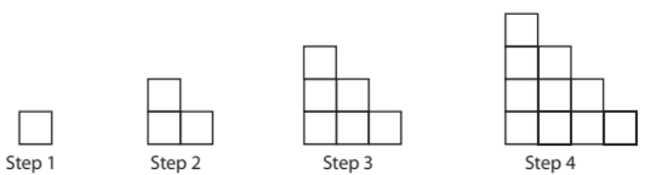

A | 5
B | 15
C | 25
D | 30

2. Consider staircases made as in problem 1. How many squares would it take to make a staircase whose tallest column was 8?

A | 8
B | 15
C | 36
D | 72

3. A pattern of dots is given by the squares below. How many dots does the 5th square contain?

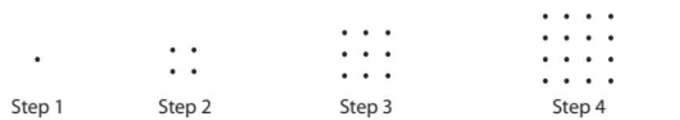
A | 5
B | 10
C | 20
D | 25

4. Using the pattern of dots from problem 3, which square would contain 100 dots?
A | 100th square
B | 10th square
C | 50th square
D | 11th square

5. According to the pattern: 2, 3, 4, 5, 6, …, what number would you expect in the 10th position?
A | 9
B | 10
C | 11
D | 12

6. According to the pattern: -1, -2, -3, -4, -5, …, what number would you expect in the 18th position?
A | 18
B | -18
C | 17
D | -17

7. According to the pattern: 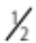, 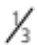, , 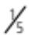, …, what number would you expect in the 14th position?
A | 14
B | 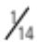
C | 
D | 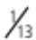

8. Lisa collects snow globes. She bought 7 and now she has 42 snow globes in her collection. Write a number expression that can be used to determine how many snow globes Lisa started with.
A | 42 + 7
B | 42 – 7
C | 42 · 7
D | 42 ÷ 7

9. A function has the following rule given by the equation y = 2x + 3 for an input x and output y. What output corresponds to the input x = 15?
A | y = 18
B | y = 30
C | y = 36
D | y = 33

10. A function has the following rule given by the equation y = 2x + 3 for an input x and output y. What input corresponds to the output y = 11?

A | x = 25
B | x = 28
C | x = 4
D | x = 7

11. Solve the equation for the variable x.
x + 18 = 111
A | x = 93
B | x = 129
C | x = 103
D | x = 102

12. Solve the equation for the variable y.
3y = 111
A | y = 114
B | y = 108
C | y = 333
D | y = 37

13. Solve the equation for the variable z.
6 + z = 73

A | z = 79
B | z = 67
C | z = 89
D | z = 77

14. Write the following statement in equation form. A number, N, is 1 less than twice 15.
A | N = 2·15 – 1
B | N = 1 – 2·15
C | N – 1 = 2·15
D | 1 – 2·15 = N

15. Write the following statement in equation form. A number, N, is 1 more than twice 7.

A | N + 1 = 2·7
B | N = 2·7 – 1
C | N = 2·7 + 1
D | N + 2·7 = 1

16. Write the following statement in equation form. 8 more than a number, N, is 51.

A | N + 8 = 51
B | N = 51 + 8
C | N + 51 = 8
D | N – 51 = 8

17. Write the following statement in equation form. 4 less than a number, N, is 23.

A | N = 23 – 4
B | N – 23 = 4
C | N – 4 = 23
D | 23 – N = 4

18. Write a rule for a pattern with inputs, x, and outputs, y, given the chart below.

Input | Output
1 | 4
2 | 7
3 | 10
4 | 13
x | y

A | y = x + 3
B | y = 3x
C | y = 3x + 1
D | y = 3x – 1

19. Write a rule for a pattern with inputs, x, and outputs, y, given the chart below.

Input | Output
1 | 6
2 | 12
3 | 18
4 | 24
5 | 30

A | y = 6x
B | y = 6 + x
C | y = 5x
D | y = 5x + 1

20. In the early morning, the temperature was 23 degrees Celsius. By the late afternoon, the temperature had risen to a hot 31 degrees Celsius. What was the increase in temperature from morning to afternoon? Define a variable, set up an equation, and solve using the 4-step process. Show all of your work.

