Chapter 8 Test Bank: Adding and Subtracting Fractions

Vocabulary:
- Equivalent  Fractions | - Denominator | - Unit Fraction | - Relatively Prime | - Least Common Multiple
- Greatest Common Factor | - Fraction | - Improper Fraction | - Simplest Form | - Mixed Number
- Numerator | - Multiplicative Inverse | - Proper Fraction

_______ The number of parts that a whole is divided into; the bottom number in a fraction.

_______ Two fractions that represent the same part of a whole.

_______ A fraction greater than or equal to one whole; the numerator is greater than
or equal to the denominator.

_______ A number written as an integer with a fraction.

_______ A part of a whole.

_______ The number that a quantity is multiplied by to produce a product of one, also known as the reciprocal of the quantity.

_______The top number in a fraction, showing the number of parts in a whole.

_______ The largest factor that any two natural numbers have in common.

_______ The smallest integer that is a common multiple of any two integers.

_______ A fraction whose value is greater than 0 and less than 1

_______ Any two integers whose greatest common factor is 1.

_______ A fraction whose numerator and denominator have no common factors except 1.

_______A fraction with numerator one and the denominator is a positive integer.

8.1 Which of the following is equivalent to 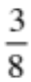?

a. 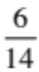 b. 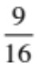 c. 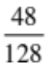 d. 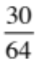

8.2 What fraction is represented by the shaded portion of the figure below?
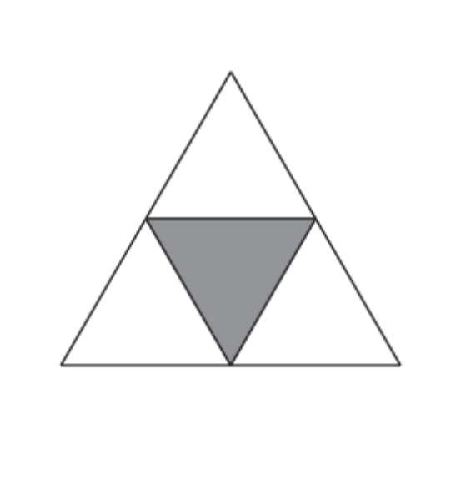
a.  b.  c. d. 

8.3 What fraction is represented by the shaded portion of the figure below?
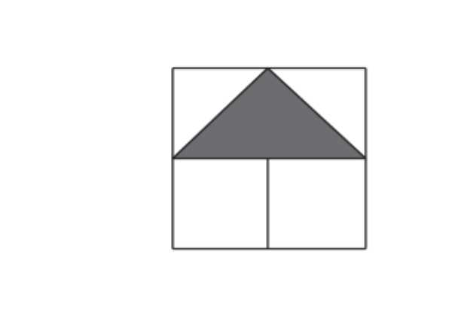
a.  b. c. d. 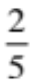

8.4 Tammy worked on her math and English homework during 8th period for 1 hour and 30 minutes. If Tammy spent 20 minutes of this time working on her math homework, what fraction of 8th period did she spend on math?

a. b.  c.  d. 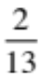

8.5 There are 12 boys in Nama’s math class. If this is of the class, how many students are in her class?

a. 18 b. 22 c. 30 d. 42

8.6 Jennifer has 40 pies to sell at the bake sale. If of her pies are apple, how many apple pies does Jennifer have to sell?

Answer: _____________________________

8.7 Find the GCF of 339 and 113.

a. 11 b. 27 c. 3 d. 113

8.8 What is the GCF of 36 and 48?

Answer: __________________________

8.9 What is the GCF of 24 and 64?

Answer: ____________________________

8.10 Find the GCF of 16, 24, and 36.

a. 2 b. 4 c. 6 d. 8

8.11 Which of the following is equivalent to 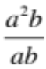?
e. a f. b g. 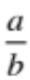 h. 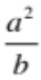

8.12 Compute the following: 3⁵ ÷ 3³.

a. b. 3 c. 9 d. 27

8.13 Compute the following: 3³ ÷ 3⁵.

a.  b.  c. d.

8.14 Simplify each expression (not multiple choice!!)

A. 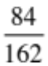 B. 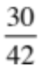 C. 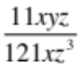 D. 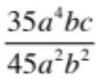

8.15 What is the prime factorization of 600?

a. 2 x 3 x 5 b. 2² x 3 x 5 c. 2² x 3 x 5² d. 2³ x 3 x 5²

8.16 Justin is making stockings for his friends and has 28 candy canes, 42 gum drops and 35 gingerbread cookies. If he wants each stocking to have the same number of each treat, what is the greatest number of stockings he can make?

a) 2 b) 5 c) 6 d) 7

8.17 Which Venn Diagram represents the prime factorization of 30 and 18?

30
18
a.
5
2
3
3

b.
30
18

5

2
3
3

30
18
c.
3
5

2
3
2

d.
30
18
2

3
3

2
5

8.18 In the space below, draw a Venn diagram that represents the prime factorization of 54 and 72. Use your diagram to compute the GCF of 54 and 72. The GCF is: ________

8.19 In the space below, draw a Venn diagram that represents the prime factorization of 22 and 8. Use your diagram to compute the LCM of 8 and 22. The LCM is: ___

8.20 Which of the following is the LCM of 12 and 15?

a. 30 b. 60 c. 120 d. 180

8.21 Find the LCM of 20 and 24. Answer: _________

8.22 In the diagram below, the hundredths grid is the whole. Use the grid to answer each of the following questions and write each answer as BOTH decimal AND simplified fraction form.

A. What portion of the grid is solid? Fraction: Decimal: ________

B. What portion of the grid is striped? Fraction: Decimal: _______

C. What portion of the grid is white? Fraction: Decimal: _______

8.23 What fraction, equal to 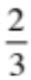, has a numerator and denominator whose product is equal to 216? Justify your answer with words!

Answer: ________________________________________________________________________

________________________________________

8.24 Write each of the following statements as a SIMPLIFIED fraction and as a decimal. (Round to the hundredths if needed.)

A. 30 out of 1,000 days Fraction: Decimal:________

B. 20 out of 22 problems Fraction: Decimal: _______

8.25 What is the reciprocal of ?

a.  b.  c. d. –7

8.26 Convert 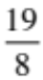 to a mixed fraction.

a. 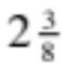 b. 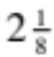 c. 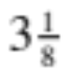 d. 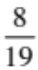

8.27 Which of the following symbols should be placed between the two numbers below?

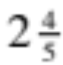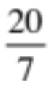

a. < b. > c. = d. none of these

A class of 30 students consists of 16 boys and 14 girls. Use this information to answer the following three questions. Simplify all fractions, if necessary.

8.28. Write a fraction with the number of boys as the numerator and the total number of students in the class as the denominator. __________

8.29 Write a fraction with the number of girls as the numerator and the total number of students in the class as the denominator. _________

8.30 Write the fraction with the number of boys as the numerator and the number of girls as the denominator. ________

8.31 Name two fractions equivalent to 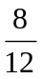. __________ , __________

8.32 What fraction is represented by the shaded region of the square below? _____________________

Compute the following sums and differences:

8.33 ¾ + ⁵/₆ = 8.34 ²/₅ + ⁷/₈ =

8.35 4 ¹/₆ + (2 ¾ ) = 8.36 12 ⁷/₈ – 7 ³/₈ =

8.37 Ben made money over his summer vacation by mowing lawns. One week he worked the following schedule: Monday 5 ½ hours, Tuesday 3 ¾ hours, Wednesday 4 ¾ hours, Thursday 6 ¼ hours, Friday 2 ¾ hours, and Saturday 2 ¾ hours. How many hours did Ben work for the week?

8.38 Shannon has 8 ¼ cups of milk in a container. If she needs to use 2 ¾ cups to bake, how much milk will Shannon have left?

8.39 Jamel, Miguel, Sam, and Tony each walked from their houses to the video store. Jamel walked ¾ mile, Miguel walked ½ mile, Sam walked ¼ mile, and Tony walked ⁵/₈ mile. Which list shows these distances in order from greatest to least?

A ¼ mi, ½ mi, ⁵/₈ mi, ¾ mi
B ¾ mi, ⁵/₈ mi, ½ mi, ¼ mi
C ¾ mi, ½ mi, ⁵/₈ mi, ¼ mi
D ⁵/₈ mi, ¾ mi, ½ mi, ¼ mi

8.40 Which statement about the mixed number 1 ²/₃ is true?

A. 1 ⁶/₁₀ < 1 ²/₃
B. 1 ³/₄ < 1 ²/₃
C. 1 ²/₃ < 1 ⁶/₁₀
D. 1 ²/₃ < 1 ³/₅

8.41 Which of the following is the least common multiple that Matthew can use to add three fractions with denominators of 6, 8, and 9?

a) 48 b) 54 c) 72 d) 1 44

8.42 Tim plans to buy wood for 2 woodcraft projects. One project requires ¾ yard of wood and the other requires 1/8 yard of wood. Each strip below represents 1 yard of wood. Which strip is shaded to show the amount of wood that Tim needs for his project?

A.

B.

C.

D.

8.43 Find the greatest common factor of 12, 24, and 36.

a) 6 b) 12 c) 18 d) 21

  - Rebecca ate ⁵/₈ of her personal pizza. Lizette ate ¹/₂ of hers, Ashley ate ³/₄ of hers, and Erika ate ¹¹/₁₆ of hers. Who ate the largest part of their pizza?
- Rebecca
- Ashley
- Lizette
- Erika

  - Analisa is using a wooden strip 7/8 yard long to make a picture frame. If she cuts off a piece that is ½ yard long, which fraction best represents the portion that is left of the original strip?

A. ³/₁₀ yd B. 1 yd C. ³/₈ yd D. ¹/₄ yd

  - Ms. Garcia wrote the following riddle on the board for her mathematics class. We are 2-digit numbers. Our greatest common factor is 8. Our difference is 32. Our sum is 80. What are the 2 numbers of the riddle?

A 8 and 48, because their greatest common factor is 8

B 16 and 48, because their difference is 32 and the greatest common factor is 8

C 24 and 56, because their difference is 32 and their greatest common factor is 8

D 64 and 96, because their difference is 32

8-47. Mr. Flores bought 5 pounds of cheese. He
used 2¼ pounds for cheese spread, 1¾ pounds
for nachos, and the rest for sandwiches. Which
procedure could be used to find the number of
pounds of cheese he used for sandwiches?

A Add 5 to the of sum of 2¼ and 1¾
B Divide 5 by the of sum of 2¼ and 1¾
C Subtract the sum of 2¼ and 1¾ from 5
D Subtract 5 from the sum of 2¼ and 1¾

8-48. The table shows the different types of pets
owned by the 15 students in Mrs. Kelser’s
Computer class. What fraction of the students
listed own a dog?

Type of Pet | Number of Students
Cat | 4
Dog | 9
Spider | 2

A B

C D

